ANNUAL ACTIVITIES REPORT OF RAJENDRA yubak sangha (RYS)
FOR THE PERIOD 2017-18
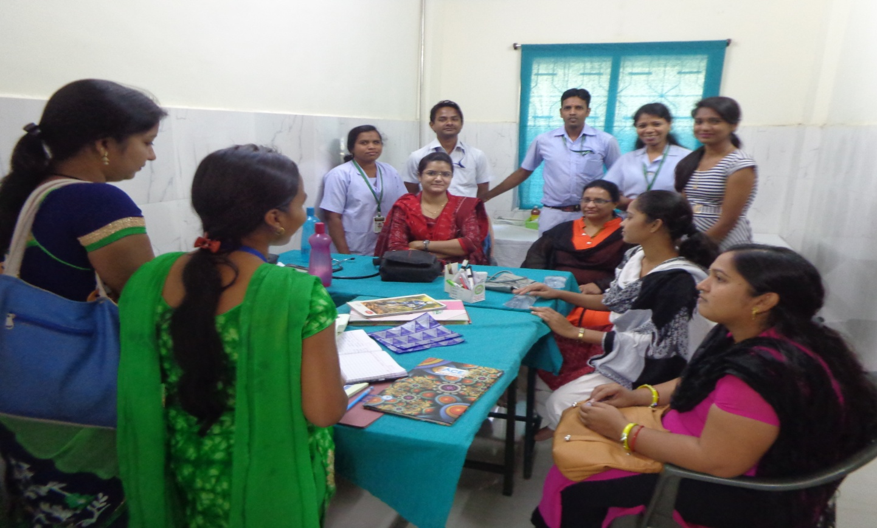
Address for Communication
At- Railway Station Road
Near – FCI Godown
Po/Dist- Balangir, ODISHA- 767001
Ph. – 06652234547, Mob.-9853200783
Email – rys.bgh@gmail.com

FORWARDS
Dear friends,
I am privileged to bring out the Annual activities Report 2017-18 of the organization RAJENDRA YUBAK SANGHA working in the district of Balangir, Bargarh,Kalahandi ,Subarnapur Nuapada & Boudh for the past 27 years. During the past years the organization as social welfare based institution tried to extend its services for the development of the rural areas, especially in the areas of the above mentioned District where it is working.
It is indeed a very auspicious occasion for me to share few words through this Annual Report. This Annual report works like an effort road towards strengthening the activities of the organization in various roots and giving a new plan of action.
During last session it has penetrated the programme on education, health, environment, child development, women empowerment, empowerment of youth & CBOs, MTH, PLWHA & other vulnerable group and rural development.
We are happy to acknowledge or sincere and appreciation to all our Donor Agencies and partner associations the Organization for their continuous support, encouragement and assistance to make our aspiration and progrmmes a reality.
We also use this occasion to extend our hearties gratitude thanks to all our members, staff and collaborators in the field and thousand of well – wishers for their kind support and involvement.
I extend my heartfelt thanks to the community women groups and volunteers who have participated actively in different activities of the organization for its successful achievement.

Thank you.
Rajendra Panigrahi
Secretary, RYS

PROGRAMME AND ACHIEVEMENT REPORT OF
RAJENDRA YUBAK SANGHA (RYS) FOR the period 2017-18

PROGRAMME SUPPORTED BY GOVT INSTITUTION
in order to increase the socio-economic and health status of the people in the area of operation of the organization the organization Rajendra Yubak sangha has carried out a numbers of activities under socio-economic & Health related issues and challenges by the support of different Govt. institutions. During the year under report the organization coming with some following efforts.
AWARD & REWARD:
The year 2017-18 is really a remarkable year in the history of the organization RAJENDRA YUBAK SANGHA. The activities taken under the year has brought the organization into the lime light as the organization has been acknowledged by the District Health Administration, for management of Urban PHC and rewarded with Kayakalpa Award. Such acknowledgements & felicitation will certainly work like an effort rod for the organization in future to achieve its target.
Training of ASHA:
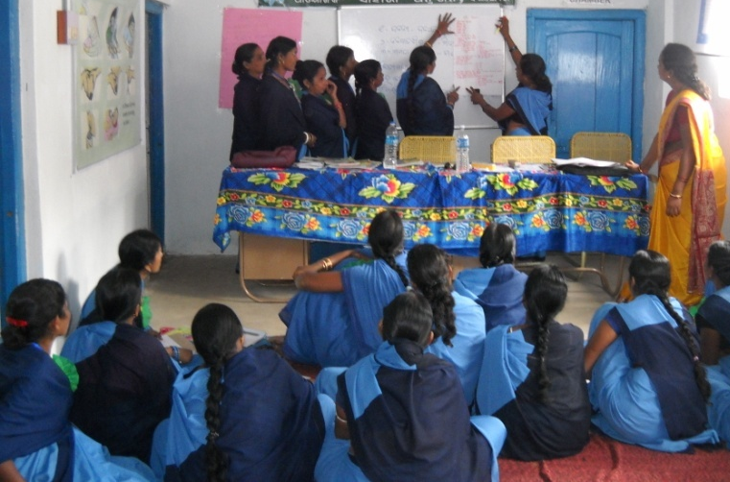
In order to reduce & control IMR & MMR it is but necessary to promote institutional delivery under skilled practitioner and for this the health administration introduced a successful institution NHM and under these engagement of ASHA is one of the most primary & important parts to achieve the goal for reduction of IMR & MMR because she is the driver of the programme in village level for executing different activities under NRHM by emphasizing the Janani Surakha Yojana and has done wonders in this connection. Hence in order to capacitate the ASHAs for the better execution & implementation of the programme of NRHM the Govt. arranged training for the ASHAs on different health related activities and the role and responsibilities of ASHA & scope & activities of Health administration. However during the year under report by the extensive support and guidance of the District health administration Balangir the organization RAJENDRA YUBAK SANGHA under PPP mode participated & conducted training of ASHAs of Agalpur, Gudvela & Loisingha Blocks of Balangir District and Atabira, Sohela & Bhatli Blocks of Bargarh District. In this connection it has organized training for ASHAs in Balangir district covering 23 numbers of Batch in Bargarh district covering 4 numbers of Batch under the said areas.
CRP Training cum Impression Programme under OLM:
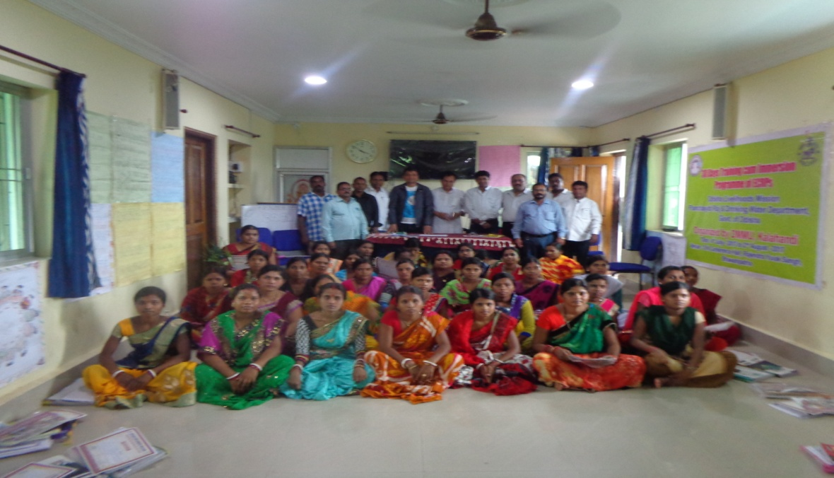
The organization RAJENDRA YUBAK SANGHA during the year under report by the support of OLM, Department of Drinking Water & Panchayati Raj, Govt. of Odisha organized CRP Training cum Impression Programme at S.N. Conference Hall of Bhawanipatna under Kalahamdi District in order to capacitate the identified CRP group from SHG regarding the beneficial schemes of the Govt Under OLM & the scope & activities under the department. Further the community were also educated about the role & responsibility of PR department for the welfare of the people & for their livelihood.
Community Process:
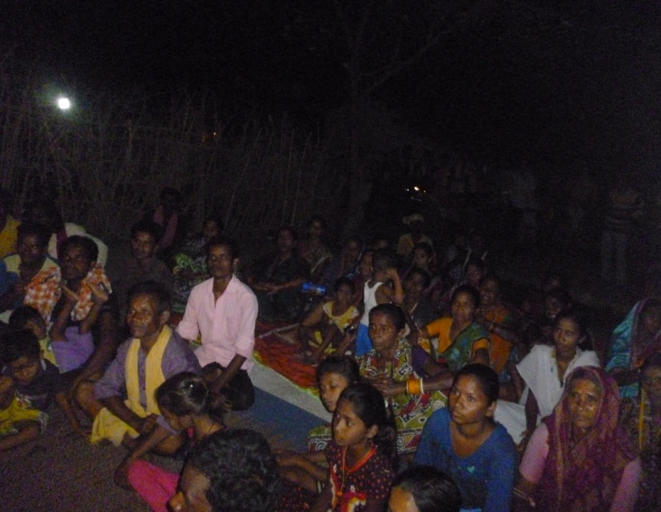
The community especial under the slum areas of the municipality and NAC areas are in very unhealthy & unhygienic condition that many times lead vital diseases. So to aware & sensitize such people the organization Rajendra Yubak sangha by the support of NUHM organized community process activities in Balangir Municipality in order to identified the vulnerability in the area so far health of the community is concerned. During the survey the following major issues were identified.
TI for Intravenous Drug User:
Day by day the use of drugs among the youth has been a fashion at the initial stage and it has been spreading like anything and is responsible for loss of human resources to a greater extent. The drug has been life killing many times and there is every possibilities for intravenous drug users to prone to HIV/AIDS as they are at high risk so far infection of HIV/AIDS is concerned. By the support of OSACS, BBSR during the year under report the organization RAJENDRA YUBAK SANGHA has been extending and implementing TI project in Atabira, Sohela, Padampur, Paikmal and Jharbandh Block under Bargarh District for the last 6 years. Under these programme during the year under report the organization has conducted Awareness and sensitization activities for drug de-addiction, Discourage needle exchange and use of unsterilized syringe, Adverse and deadly effect of intravenous drug use, Causes and symptoms of STI/ RTI & HIV/AIDS, Harm reduction through motivation and mobilization and Abscess management. Besides these the organization also educated the group on the Role of ICTC and Govt along with the donor & implementing NGO, Facilities for the victims, and role of the victims. However the organization also promoting Condom and arranging social marketing of condom among them & the identified drug users were provided support and care along with motivation and linkages for reduction, management and control of HIV/AIDS.
MAAGRUHA PROJECT :
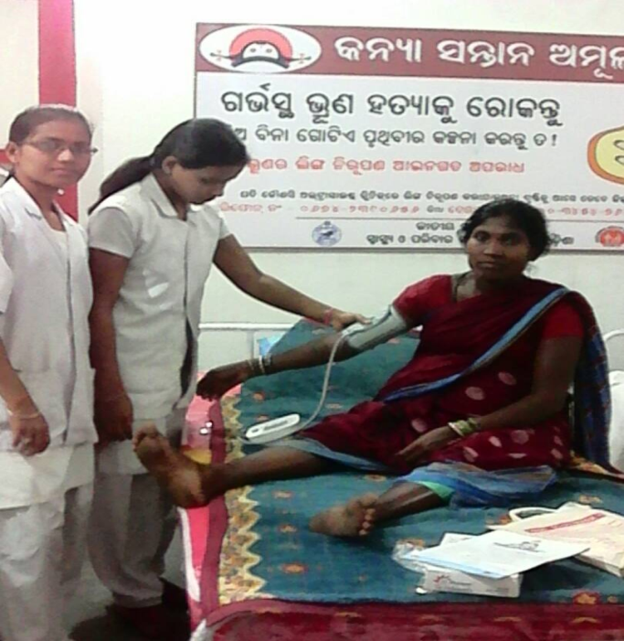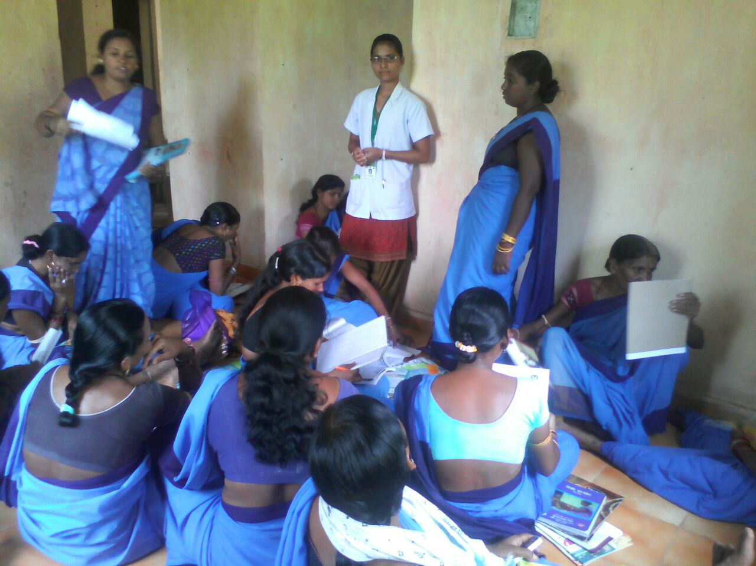

The organization RAJENDRA YUBAK SANGHA during the year under report by the support of NHM, Department of Health & Family Welfare, Govt. of Odisha started 4 numbers of Maa Gruha 4 Blocks namely Turekela, Bangomunda, Muribahal & Belpada under Balangir District. In the Maa Griha proper care such as ANC, PNC of the pregnant women were being taken up regularly.

skill development training under vedant foundation
During the year under report the organization RAJENDRA YUBAK SANGHA by the support of Vedant Foundation, Mumbai carried out the following skill development training camps in its area of operation.
Training on Mobile repairing:
Like previous year by the demand of the target group during the year under report the organization RAJENDRA YUBAK SANGHA organized a training camp on Mobile repairing for the interested youth at Tusra & Bargarh during the year under report where 42 numbers of trainees were enrolled and provided training on different techniques applied in beauty culture along with tools and equipments used in the trade. The training has a good impact on the trainees and some of the trainees earned by establishing mobile repairing centre.
Computer Training:
Looking to the market need and realizing the unaffordable capacity for computer education of the students/ parents RAJENDRA YUBAK SANGHA started a training centre on computer education AT College Chowk under Balangir Town for the interested students in a very nominal price by admitting 80 numbers of students of the locality. To impart the technique on DCA one expert instructor in the field is engaged.
Tailoring & Embroidery Training
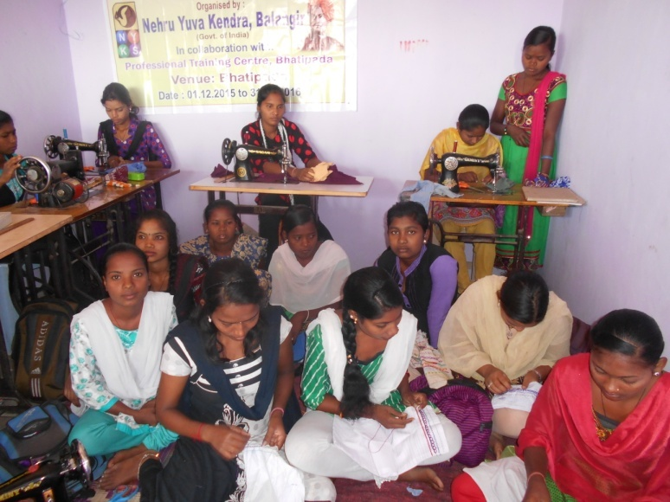
During the reporting session some Youth girls who have already interest on tailoring were admitted in the training centre at RYS Training Center Railway Station Road Balangir on the modern and improved tools and machineries used in tailoring & embroidery along with stitching technique of the same. 60 numbers of girls were trained during the year under report. The training was of 3 months duration.
Health PROGRAMME:
Govt. has been taking much initiation and has been conducting a numbers of projects and programmes promotions of health status of the people and that is one of the prime areas of concern of the Govt. For achievement of the goal & mission in the rural belt National Rural Health Mission is working in a war footing way. But inspite of the entire endeavor the service under health related activities is yet to be universalized because of lack of initiative apathy at people’s level, disorganized effort of health providers at time, high rate of social stigma, emphasized on traditional system etc. So to drag out the people of the inaccessible areas of different op[erational Blocks of the organization RAJENDRA YUBAK SANGHA & in this connection the organization has initiated the following steps.
Awareness on Malaria, Dengue & Diarrhoea:
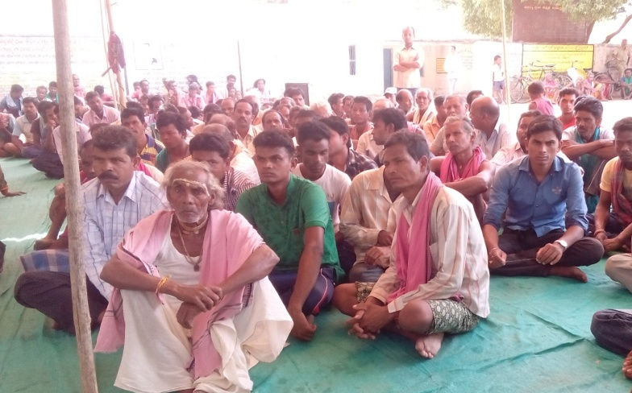
The organization RAJENDRA YUBAK SANGHA committed to intervene in the field of Health related programmes and have emerged as a responsible organisation to the specific needs of the public of the rural community. Due to lack of literacy and unconsciousness of the community of remote part the people of this part of the world are suffering a lot so far effecting on Malaria Dengue & Diarrhoea is concerned and it is due to improper sanitation, carelessness, lack of knowledge and information and thus the morbidity and mortality have been increasing day by day. So to make aware the people of the areas of operation of the organization awareness meetings were organized by the RAJENDRA YUBAK SANGHA in 20 villages of Tutrkrla,, Khaptakhol, Muribahal Blocks of Balangir district & Padamput & Paikmal Blocks of Bargarh District relating to prevention and control of Malaria Dengue & Diarrhoea. These programmes were conducted during the year under report. In the camps the participants were warned on the deadly effect of Malaria Dengue & Diarrhoea. ICDS supervisor, NGO activists and local health staff attended the awareness camp to impart their valuable suggestion and guidance. The intervention in the effective strategy for control of Malaria Dengue & Diarrhoea influenced the community people to a greater extent for taking preventive & precautionary measures. However some points were emphasized by the RPs in the camps were cleaning of their surroundings, cleaning of water bodies, use of impregnated bed nets, optimum utilization of existing health services, take boiled water and hot food etc. The programme was quite felt need of the rural people who will be getting access to all health facilities from the health department in future.
Health Care Centre:
For the last 6 years the organization RYS has established a health care centre in the office premises where Free Health Check-up is being provided along with medicine on nominal price is made available for the needy. A large number of rural people of different age-group and different categories were examined by the part time medical officer engaged for the purpose and provided with medicine as per the availability after proper diagnosis. Some patients in serious condition were referred to the Hqrs Hospital.
Mobile Health Service:
The Govt. has taken the responsibilities to provide health care & support to the people and in this connection it has implemented a numbers of activities. Inspite of implementation of the same through NHM & health administration the people of some remote concern are still debarred from getting different health service which may be the negligence ignorance, lack of initiative apathy or lack of information & education. So with a view to overcome such problems and to provide health service at the door step of the people in need the organization initiated a process and arranged a mobile health care service in different parts of Balangir, Subarnapur & Bargarh District during the year through which a numbers of people who are in need of health services were being benefited through this mobile unit.
Health Care & Support:
It is observed during different FGD & one to one interaction with the high risk group including FSW, MSM & IDU that the Person leaving with HIV/AIDS are being neglected by the society inspite of all sorts of awareness given to the community. Without having any care or support their health status has been deteriorating to a greater extent. Hence realizing the fact the organization RYS used to provide care & support to such group through its counsellor & outreach worker and at times tagging them to the health administration. Under these programme a numbers of MSM & Tran gender Hinjda who are the most vulnerable groups are also being supported.

AIDS Awareness Programme:
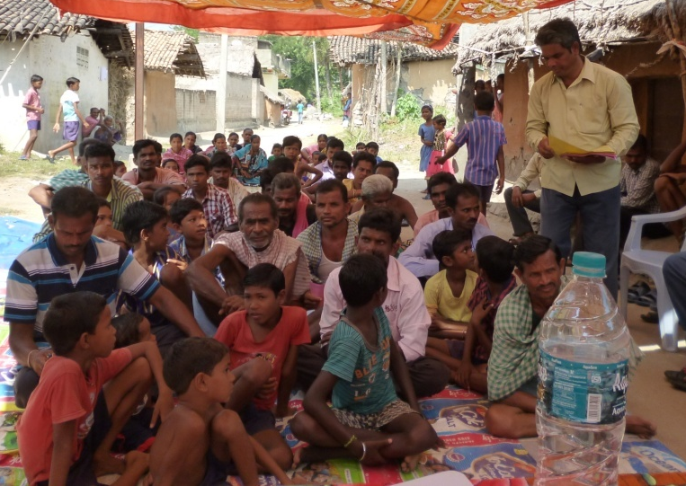
Recognized as an emerging disease only in the early 80s, AIDS has rapidly established itself throughout the country and is likely to endure and persist well into the 21st century. AIDS has evolved from a mysterious illness to a global pandemic which has infected more than ten millions in less than 25 years. Over the past few years HIV/AIDS have become a dreaded disease and is spreading very fast. The tribal areas of the state are also not immune from its grip. As far as the present level of knowledge is concerned there is no such curative medicine for it. Th e only way out is to prevent it. Thus, the organization RAJENDRA YUBAK SANGHA has tried its level best to make the people conscious to prevent this dreaded disease through awareness creation. In this Endeavour, various rallies, community meetings and street plays were organized by the organization during the year under report. Further the world AIDS Day was also observed with rallies and awareness meetings on 1st December this year. The volunteers of the organization has conducted a series of meetings with the most vulnerable groups like; truck drivers, rickshaw pullers and migrant labours at different places in and around Bargarh & Balangir District and made them aware about this ghastly disease of AIDS. In the awareness camp organized at different villages people were urged by volunteers to follow different preventive methods during their sex activities to save themselves from the spread of HIV.
AWARENESS ON TB:-
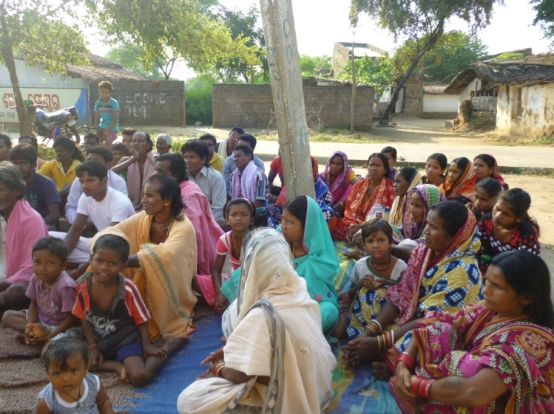
TB is a most infectious disease caused by bacteria and the inspection generally spread through air from one to another. TB infection is much high in rural area of economically weak and illiterate and living in unhygienic environment. But T.B is completely curable with DOTS which are being supplied to patients free of cost. In view of the above it was very important to create a positive and inspiring environment among the rural people to fight against life killing diseases lik e T.B. Hence to make the people aware the organization RAJENDRA YUBAK SANGHA arranged numbers of awareness camps in different villages of Atabira & Sohela Blocks under Bargarh District during the year under report. These programme influenced the community and they acquire knowledge and skills regarding preventive and creative measure and access to medical case as and when necessary.
Diabetics Camp:
It is observed during the pilot survey that the people of this part of the world are completely unawareness regarding the deadly effect of Diabetic along with its causes, symptom & curative measures. Further due to lack of information & poor initiative apathy the miseries of the people increased substantially and it becomes deadly many times. Hence realizing the fact the organization RAJENDRA YUBAK SANGHA carried out 3 numbers of diabetic testing camp 5 numbers of Urban Slum areas under Balangir Town by inviting the medical professionals of the local UPHC. The experts attended the camps provided tips as well as medicine for the same.
Cancer Screening Camp:
In spite of Govt.’s greater area of concern to de-addict people from use of gutka, tobacco, alcohol, cigarette, bidi drugs, tambakhu etc. the nsame has yet to take a desired shape rather day by day people are so callous & careless that the use of such intoxicating materials are increased to a greater extent which in later stage leads to cancer. Cancer is a serious & life killing disease. due to cancer the effected people lead very pathetic life and it is observed that such types of patients are neglected & much time hatred by the community. Further the people are completely unaware about the causes & prevention of of cancer. Hence to aware the people on the said disease the organization RAJENDRA YUBAK SANGHA conducted 5 numbers of sensitization meeting in different locations of Balangir Town by the support of UPHC and organized cancer screening camp in the said locations.
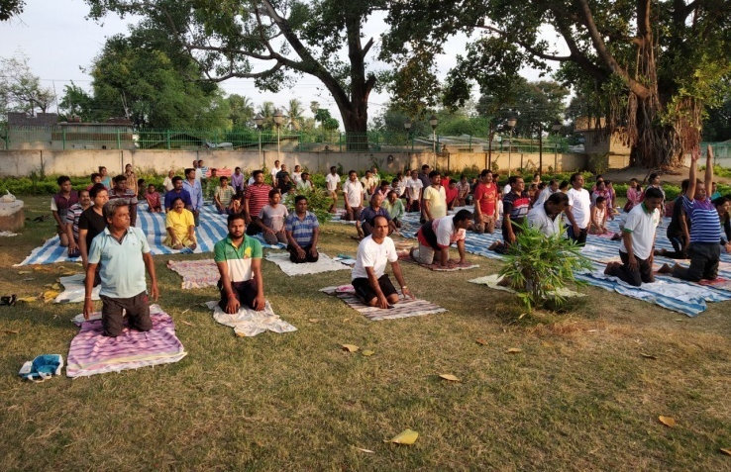
Yoga Sibir
Practicing Yoga can help the people in the task of providing holistic education and keeping the body and mind in sound condition. The purpose of yoga education is not only to impart knowledge but more importantly to tap the hidden talents and potentialities of the people and helping them to develop physically, intellectually, morally and spiritually. Keeping in this view of the benefit of yoga and naturopathy the organization RAJENDRA YUBAK SANGHA has celebrated the international Yoga Day at District level in the office premises of the organization on dt. 21st June 2017. In the camp the expert Guru was invited and he was imparted training as well as conducted practical forms on Yoga for the benefit of the participants. However the activity was attended by 100 numbers of participants.

Blood Donation Camp:
Blood donation is a noble work as it helps to lot of people who are in need of blood during their health related problems. It is seen that a numbers of people die due to want of Blood and many times some rare blood groups are not available in the blood bank. So with a view to sensitize and encouraged the youth the organization conducted a sensitization meeting on Blood donation, However on the day a Blood donation & testing camp was also organized at Saimandir under Balangir Municipality during May 17. By the consent of the participants the organization RAJENDRA YUBAK SANGHA keep the name of the participants along with their blood group & phone numbers so that they will be informed as the time of need of blood for patient

EDUCATION:
Education is one of the important components that contribute a lot for the progress of human mass in all most all sectors. Without education we cannot dream of anything good because it occupies a very important significant for the development and progress of human being so far the promotion of education our Govt. has been accelerating a number activities to educate the people of all categories and all walks of life. But it is a matter of regretted that inspite of all sorts of programmes and projects the meaning of education is yet to be reached to all the people and the promotion of education is yet to take a desired shape because of lack of information motivation, initiative apathy an awareness. Hence understanding the fact the organization RAJENDRA YUBAK SANGHA has carried out the following activities in its operational area during the reporting session.

Free Coaching Centre for ST/SC
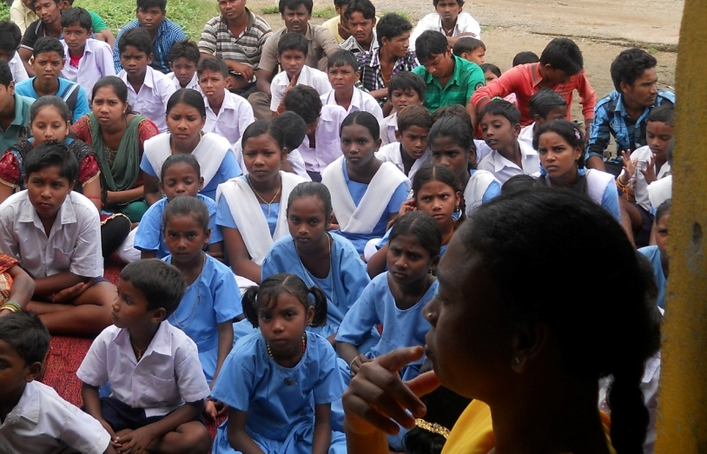
In spite of the protection given to the ST/SC population by the constitution of India (1950) they still remain the most backward ethnic group in the country and so in the district and they are neglected & debarred from the three most important indicators of development i.e. health, education and income. The ST is most backward as compared with the general population. It was observed that after long period of intervention for the development of the group the same has not made any significant impact in improving the condition of the ST and the cause every time is lack of education. So to promote education among the ST/SC Student of the area of operation of RAJENDRA YUBAK SANGHA the organization conducted 2 numbers of free coaching centre for the ST/SC student of the area at Turekela & Bongomunda Block with view to make them capable to cope with the present education system in an integrated way for their future course of action. In both the centres 64 nos of ST students from the different locations of the area were enrolled. The programme helped a lot to the ST/SC students.
Adult Literacy:
The people specially the female of Gudvela & Deogaon Blocks, who are non–literate or partly literate were motivated to continue their education either in literacy centre or in existing CE centre of their concerned area. Further the neo literate were encouraged to involve actively in the activities of AEC which are being organized from time to time. Some awareness activities were also taken up by the organization RAJENDRA YUBAK SANGHA for promotion of literacy status of the area. In the awareness activities the following activities were taken up.
- Organized some training for the educated youth to be engaged as voluntary instructors.
- Organized literacy classes for the non-literate female.
- Organized some awareness activities to motivate the neo literate and non literates to avail the literacy classes either in AEC or in literacy centres.
Participated in the activities of local AEC of the area under Sakhar Bharat.
Library and information:
Library is social institution offering information dissemination services based upon knowledge for various groups on social, political economic, cultural and other matters. The library is treated as a local gateway to knowledge, provides a basic condition for lifelong learning. So realizing the fact, the organization RAJENDRA YUBAK SANGHA established a library unit in the office premises of the organization at Railway Station Road under Balangir Town. The library has been equipped with various books to cater to the needs of different categories of readers. The library unit has provided following benefit to its reader.
- Creating and strengthening reading skills and habits in children from an early age.
- Promoting awareness of culture heritage, appreciation of the Arts, scientific achievements and innovations.
- Ensuring access for peoples to all sorts of community information.
Supporting and participating in literacy activities and programme for all age groups and initiating such activities of necessary.
WOMEN EMPOWERMENT:
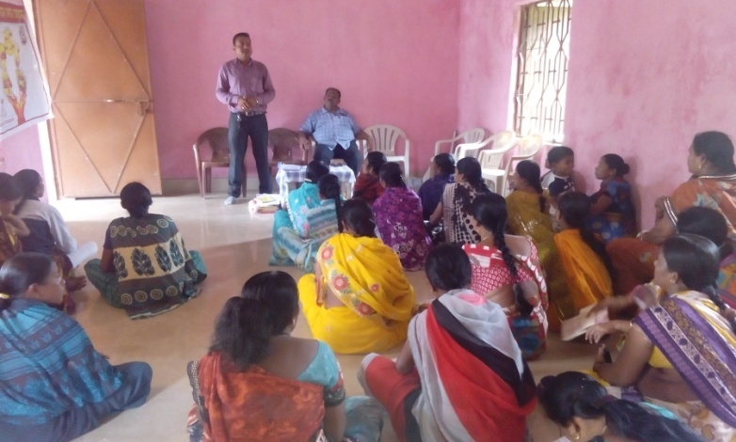
Empowerment of women in all the sectors is the need of the hour so as to progress of the country and would the Govt. has been putting in Herculean effort to ameliorate the states of the women and in this connection execute a numbers of projects and programmes. But the development is yet to take a desired shape. No doubt the development in the sectors has been possible to some extent by interventions of various activities relating to empowerment of women but the universal achievement is yet to be possible especially in the rural India because for some key issues like disorganize effort, lack of building, poor infrastructure etc. Hence realizing the issues and challenges for development of the women our organization RAJENDRA YUBAK SANGHA executed the following activities in the operational area to achieve the goal to some extent.
SHGs Promotion & Strengthening:
Women’s empowerment is an important agenda in development efforts. The organization aims at empowering women through formation of and promotion of women SHG. These WSHGs are engaged in different types of economical activities. The organization RAJENDRA YUBAK SANGHA has formed 16 SHG in different villages under the area of operation of the organization during the year under report. It also made efforts for the capacity building of the SHG members by way of imparting different training programmes by which the members of the SHG can be active participants in the process of sustainable development. The object of the programme is to generate employment opportunities among neglected women groups at their native. Most of the WSHGs meet the smaller consumption and emerging needs of its members from its own savings and common fund generated earlier. But to enhance their business the funds available with the SHGs are found quite inadequate to meet the needs hence link the all good running SHGs with the local financing barks and pursued to finance on the basis of their actual working. However due to such attempts of the organization it did able to bring these women to mainstream of the society.
Capacity Building Training of SHGs :
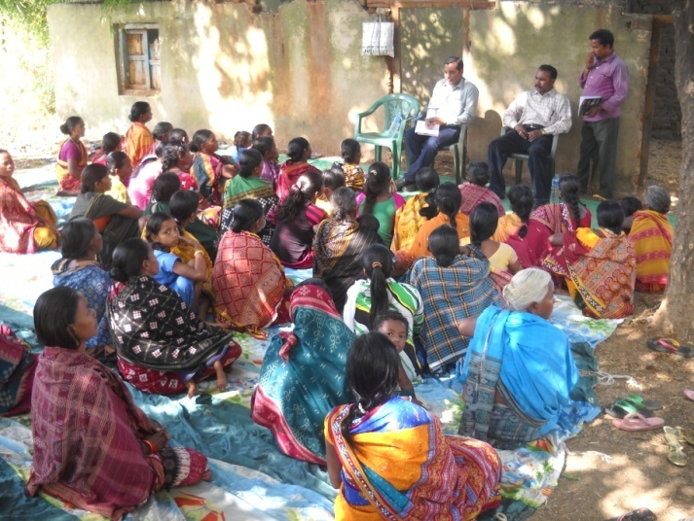
For the smooth management of SHG the members of different SHG were provided training on the following content. The programmes were taken place at Bargath & Balangir. In the training camp the following content were covered & to train the group experts of the concerned field were invited to the camps as resource persons who imparted training on the concept of SHG and the content includes Poverty & its adverse affect on women, SHG aiming at eradication of poverty, Group management and mobilization, Role Responsibilities of leaders & members, Saving and credit, Gradation and linkages & Maintenance of records.
Training on Income Generation :
The organization RAJENDRA YUBAK SANGHA initiated step towards development of vocational skills of SHG members and in this context it has organized some vocational training courses for the SHG members of its operational area 7 nos. Block during the year under report.
- The organization RAJENDRA YUBAK SANGHA like previous year during the reporting period the organization arranged training at Titilagath NAC & Block area. The training camp was based on small and petty business like phenyl making. In the training 22 numbers of MTH youth were benefited. To train the group on the trades MCM on the said vocations were engaged. However to market their products the organizations people were also taking initiatives.
- Training on rice processing was organized at Sikabehenga under Puintala Block for the poor SHG members to provide them income generating option for their sustainable livelihood. The partnership of the organization RAJENDRA YUBAK SANGHA and the beneficiaries brought outstanding achievement so far benefit aspect of the poor is concerned.
- The organization RAJENDRA YUBAK SANGHA arranged training programme on spices making at Tulsinagar for the SHG leaders of the operational area. In the training near about 33 SHG leaders & members of the area were trained on the technique of sweets making. .Further the trainees were also provided training on quality control, packaging, costumer dealing and marketing of different varieties of sweets. This business provided ample scope for the SHG to enhance their economy sector
Financial Support to CBOs :
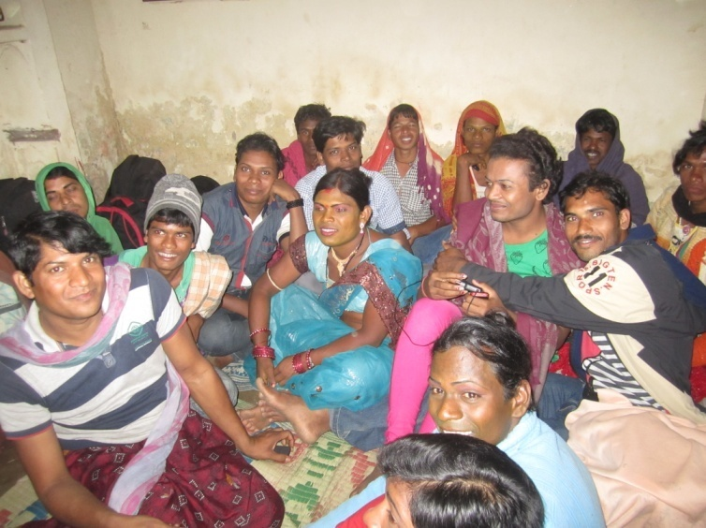
It is seen that the people belong to MSM, IDU & PLHIV, MTH group are being neglected in the society. The livelihood system of such people of the operational area of the Association RAJENDRA YUBAK SANGHA is very alarming. Looking to the situation the Association RAJENDRA YUBAK SANGHA by its own effort supported financial assistance to the CBOs promoted under the organization among the MSM, IDU & PLHIV & MTH in order to provide them livelihood option so that they will start their individual business on some suitable vocations. Further the CBS were trained under the vocations like Poultry Farming, Goat Farming, Vegetable Vending & other petty business. However under these programme Lxminarayan MSM CBO, Maamanikeswari MSM CBO, Help Trust for PLHIV & MTH, Dhanwantari Baidya Sangha & ASTHA IDU CBO were provided with financial support. The partnership of the Association RYS and the CBOs brought outstanding achievement so far benefit aspect of the members of the CBOs.
FOREST & ENVIRONMENT
The population in India has increased to an alarming condition and now it is exploding like anything in spite of several measures. Again to fulfil the need of the people the production has also been increased to a large extent and thus pollution and environmental degradation has increased substantially & threats the human mass on their survival. To overcome such problems and to increase the environmental status the Govt. of India has been putting in Herculean efforts but the same has yet to be achieved up to the mark and the alarming condition in the environment sectors is mainly due to lack of awareness commitment and coordinated efforts at all level. So for the augmentation of the environmental situation, keep the ecological balance in a proper condition and to participate in this global issue the organization RAJENDRA YUBAK SANGHA during the reporting period coming with some following efforts. However a short description of the activity taken is given here under.
Plantation Programme:
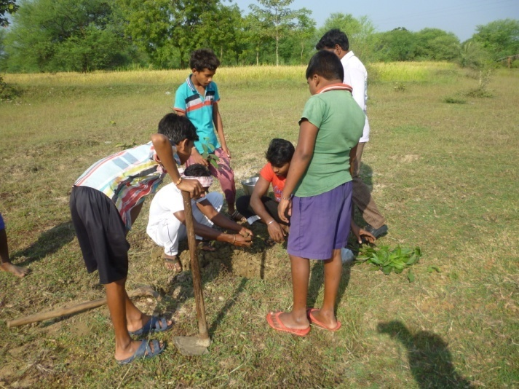
The Organisation RAJENDRA YUBAK SANGHA like previous year this year also celebrated the Banamahotsava at Khujenpali on 6th of July 17 and had taken plantation activities in the school campus at the wasteland of the area and on the roadside of the village by taking the active support of the volunteers, youth, students and SHG members of the village along with the staff and numbers of the organization. To enhance the condition of degraded nearby forest of Guja of Ulunda Block plantation & phase plantation was taken in the area on massive scale by the active cooperation & participation of the people. 1400 numbers of plants like Horticulture, medicinal & fruit bearing plants were being planted at Guja Forest. The local people along with the members of the organization are entrusted the responsibility for caring the plants. By the intensive & active participation of the local community the association has taken up avenue plantation on 1.5 Kms. from Mahkurpali 300 numbers of papaya plants & 250 numbers of drumsticks were supplied to the individual of Balangir & Puintala Block for backyard plantation. However the people were also supplied knowledge regarding the procedure of plantation through demonstration.
Nursery and Seedling:
Like previous years the organization RAJENDRA YUBAK SANGHA has raised a nursery in the project area and around 25,000 saplings, mainly horticultural, fruits bearing, vegetable and medicinal plants have been raised and nurtured. The plants & species were distributed & sold to the individual, SHG members, Farmers & Household on a very nominal price for backyard plantation, promotion & establishment of kitchen garden, for vegetable & horticultural farming. In the period of reporting the organization arranged an orientation camp for the people of Khujenpali under Balangir Block to educate them about some technique of kitchen garden, and horticultural & vegetable farming.
Seeds & Herbal Products:
From the very ancient period the knowledge herbal, medicinal and Aromatic plants (Banasaudhi) were in much demand. But unfortunately people are getting far away from this life saving herbal products and the ancient knowledge could not proceed forward due to emergence of Allopathic system of medicine, though the use of medicinal and aromatic plants was there for treatment purpose but without any documentary evidence it has lose its potentiality and demand. But now the same is in much demand for use of medicinal and aromatic plants by all developing countries and as such the overall trade of crude medicinal and aromatic plants is about seven billion dollars and is on increase at the rate of 7% per annum. Keeping in view of the crucial linkage between common diseases of rural communities with medicinal & herbal plants available in the locality the organization RYS promoted herbal seeds for plantation & use of herbal products to use as medicine for different diseases. The organization also prepared some herbal products by the experts and sold to the individual with a very nominal price. The promotional activities educated the rural community of Ghuna, Biramunda & Jamut G.P. of Gudvela Block to access to the herbal practice.
programme on Agricultural
Agricultural farming is directly linked with sustenance of rural economy of the poor community. It is the largest income generating source of India where 80% people are engaged in either ways But due to un even rain, recurring drought, lack of knowledge on modern and improved technologies, over concentration on traditional crop, maximum utilization of chemical fertilizer etc the people especially the poor & marginal farmers and agricultural labourer suffer a lot in their economic sector and at times without having any supplementary source of income they used to migrant to different unknown and exotic places to earn their livelihood. Keeping in view of the problems, the organization RAJENDRA YUBAK SANGHA in order to bring a change in the traditional practice & to make the farmer capable to fight against the situation and with a view to provide new technique on agricultural activities organized the following activities with the support & guidance of the experts from ATMA during the year under report.
Sensitization Camp:
Due to various factors such as low rain fall, adoption of traditional method for cultivation lack of knowledge, information and training on improve technology, use of old method, lack of convergence and networking, lack of initiative apathy etc. have lead to low productivity and straight away affect the economy of the poor farmers which in turns bring them health hazards, mal nutrition, at times starvation. So in order to bring up the condition of the farmers & farming sectors the organization RAJENDRA YUBAK SANGHA has taken a lead role in the operational area by the guidance of the experts & arranged sensitization camps in 15 locations of Saintala, Balangir, Gudvela & Deogaon Blocks under Balangir District. During the camps the farmers of the concerned areas were encouraged and educated on the following points.
- Motivated & mobilized to take up activities like maize cultivation, cultivation of ground nut & sunflower.
- Sensitized the group regarding the beneficial schemes of the Govt. for the farmers & farming & crop insurance under financial inclusion.
- Educated the small & marginal farmers about the scope & activities of ATMA, different improved variety of seeds, subsidy paid under different loan and purchase of equipments, participation of farmers for BGREI, Khadya Surakshya Mission & its activities & support, farming other than paddy & its benefit etc.
Training of Farmers on vermin compost
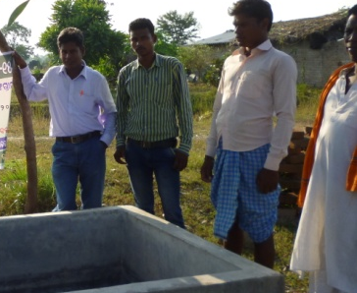
For the sustainable economic development of the farmers the organization conducted 5 numbers of training camps regarding different aspects of farming during the reporting session. In the training near about 235 numbers of farmers of the area were trained on as how bio-compost has been produced from bio-degradable solid waste and how the compost has been more effective than the chemical fertilizer for faming. Further the participants were also made understand regarding the adverse effect of chemical fertilizer on agricultural land as well as on environment. The participants were encouraged to use bio-compost in place of chemical manure because bio-compost has not only make the agricultural land more fertile by keeping the humus content of the land but also has good impact on up gradation of environmental situation. Further they were capacitated with modern technique of cultivation with regards to optimization of land, soil & water management, which form the main occupation of large percentage of the normal population. The farmers were also trained regarding control of different diseases that effected to the crops. Again the farmers of the area were trained on different technique of cultivation.
Training on Mushroom Cultivation:
Mushroom cultivation now a day is one of the better farming in farm sectors that provide ample opportunity for the farmers group a better earning source. Because marketing of mushroom is very much encouraging in the district of Balangir as well as other part of the state and the some has been sold like hot cake in the market. Hence the organization RAJENDRA YUBAK SANGHA arranged training programmes at Kudaqsingha, Nuapada & Sikachhida of Balangir Block for the SHG leaders of the operational villages of the organization. In the training near about 56 farmers of the area were trained on the technique of cultivation of mushroom of different types. To train the group experts were invited as Resource Persons. During the training the farmers were oriented on the latest and innovative technique of mushroom cultivation. Further they were oriented
Promotion & sensitization of Farmer’s Producer Group:
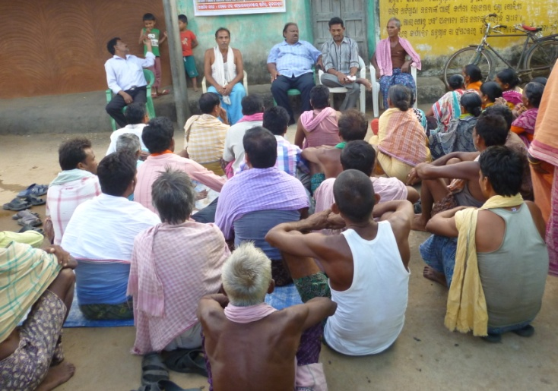
Although agriculture contribute to GDP is hovering around 15 %, it provides employment to 56 % of the Indian workforce. The growth of some commercial crops has significant potential for promoting exports of agricultural commodities and bringing about faster development of agro based industries. Agriculture not only contributes the overall growth of economy but also reduce poverty by providing employment and food security to major part of India. The milieu of the Endeavour is growth of agriculture and allied sector and economic prosperity of rural farmers and establishes effective integration and synergy between agriculture and agro-based industries. Again there have been no appropriate technological interventions to play role for better output and reduce the drudgery of the rural farmers. Hence at this situation promotion of federation among the farmers or Farmers Producer Organization (FPO) will certainly provide ample scope for the farmers to address their problems in an objective directed manner to increase the socio-economic status of the farmers. So realizing the fact the organization conducted 4 numbers of sensitization programmes for promotion of Farmer’s Producer Group.
Awareness Programme:
It is found that the people of many a parts are completely unaware about different activities relating to health, sanitation, legal based activities etc. and for the same the poor innocent mass are suffering a lot in all most all the sectors and they are being exploited many times by the touts and notorious persons along with nasty politicians. Hence to educate the mass on some important fundamental issues and challenges the organization RYS carried out the following awareness activities in its operational area.
Swachha Bharat Mission:
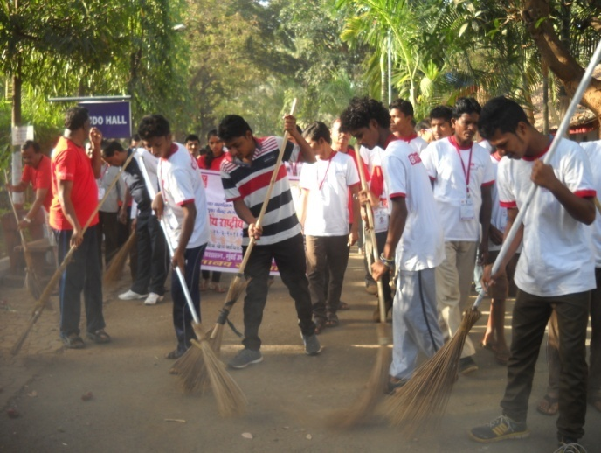
Sanitation quality of a society reflects on the healthiness of the society. It is the prime necessity for a healthy and vibrant society. The people are unaware of the effects of their different unsanitary Practices. They throw their waste all where and do not care to clean water bodies like ponds, tube wells, open wells from which source a number diseases spreads their tentacles. Therefore the organization RAJENDRA YUBAK SANGHA organized 17 numbers of awareness camps on sanitation aspect under Swachha Bharat Mission. There it was emphasized to have a clean sanitary environment for health and hygiene in different location of Balangir Town & Kantabanji NAC during the year under report. They were made aware of keeping their surroundings, water sources, drains and road side clean. They were advised to drink only boiled water of tube well water. They were advised to utilize the Govt. programme of
Subleased latrine and use them for their defecation.
Waste Management:
Following points raised and discussed thread bare in the camp.
- Water holding and water management.
- Water and air borne diseases & prevention technique.
- Installation and use of latrine and take the benefit of installation of IHHL.
- Use of Village garbage bin & Disposal of waste water.
- Management household and community waste.
- Students were demonstrated preparation use of school garbage bin.
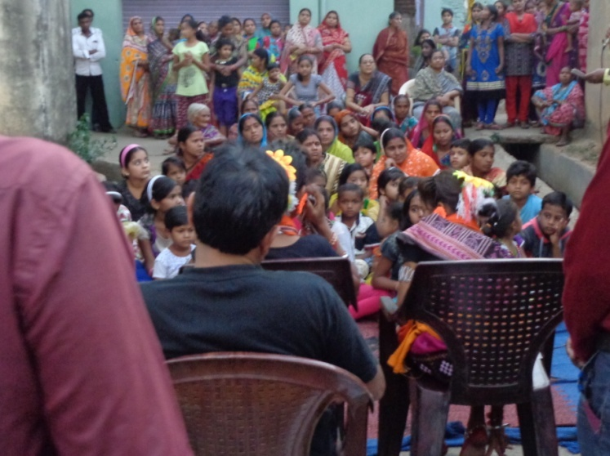

For the management of waste in a sustainable way to overcome and reduce the environmental degradation the people of this part were aware these negative effects of solid waste and the procedure for management of the same. However the organization RAJENDRA YUBAK SANGHA carried out following activities in its operational area.
- SHG members of a number of villages of Madhiapali, Kurul & Mirdhapali G.P. of Balangir Block of the district were aware about the management of house hold and community waste as how Bio-fertilizer would be prepared out of the biodegradable waste.
- Village dustbin had been promoted among the villagers in number of villages.
- Students were demonstrated on management of school waste and preparation and use of school dustbin.
- Demonstration on construction compost pits were also done in number of villages for the farmers and SHG members.
AWARENESS ON DDUGKY:
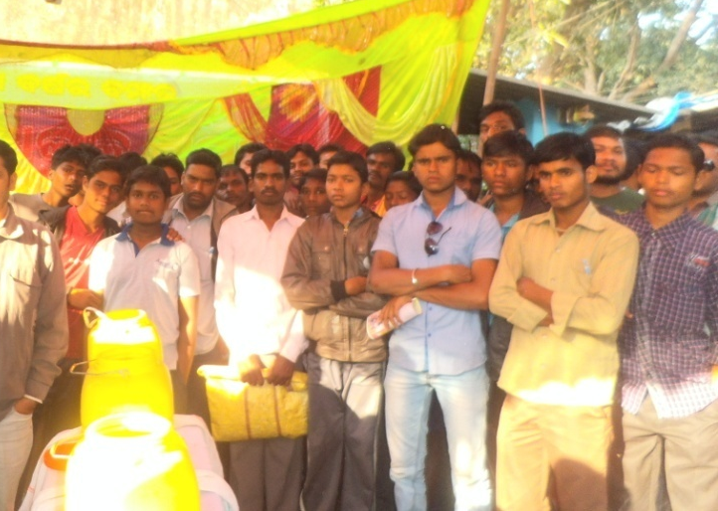
Dindayal Uapddhyaya Gramin Koshal Yojana (DDUGKY) is the flagship outcome-based skill training scheme of the new Ministry of skill development & entrepreneurship (MSDE).The objective of this skill certification and reward scheme is to enable and mobilize a large number of Indian youth to take up outcome based skill training and become employable and earn their livelihood. However to aware the Youth regarding the benefit under the scheme DDUGKY, monetary reward would be provided to trainees who are successfully trained, assessed and certified in skill courses run by affiliated training providers the organization RAJENDRA YUBAK SANGHA conducted 6 numbers of awareness activities in Sonepur & Balangir district during the reporting period.
Digital Literacy & Awareness:
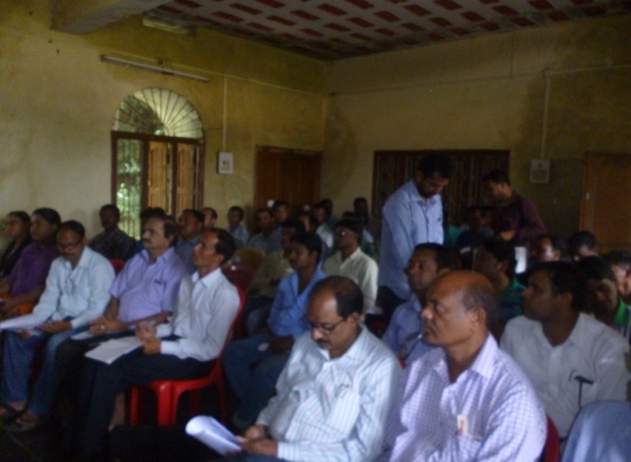
It is the age of digital era. The Govt. has given much emphasis on digital activities starting from information technology to money transaction along with Adhar & PAN linkages, ticket booking etc. But it is seen that most of the people even educated people are not aware of digital literacy. So to aware, educate & motivate the people regarding the digital literacy the organization RAJENDRA YUBAK SANGHA arranged 30 numbers of awareness activities in different villages of the Balangir district & some part of Bargarh district. Prior awareness of the people the organization orient some youth volunteers of the district regarding digital literacy and its scope and activities & beneficial aspects. In the awareness meeting the following points were emphasized.
Awareness on Road Safety
Due to increase in population, urbanization, the so called fast & advanced world, modernization and luxury life of people the numbers of vehicles on the road is increased more than the expectation. To control and avoid accidents the Govt. has promulgated the traffic rules which is violated many times and thus accidents occur large in number by taking a numbers of lives and injured innumerable. It is observed that due to Lack of good road sense unaware of traffic rules. Jumping signals and not knowing what lane driving means, always results in accidents. Further other major causes for road accidents are speeding beyond the limits inside the town area; Drunken driving, overtaking dangerously etc. so to aware people on the above mentioned problems to avoid accidents the organization RAJENDRA YUBAK SANGHA organized awareness activities in 3 locations of Balangir District during celebration of road safety week.
Youth Development:
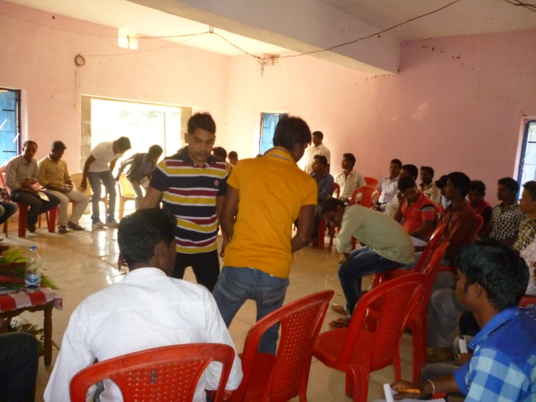
A number of youth today are in distress and disorganized state. To fulfil their requirements they do not hesitate to adopt all sorts of foul means. Further due to lack of leadership quality and as there is no supplementary source of income a strong undercurrent of unrest are flowing among them which not only create havoc for the society but also hamper a lot in the progress of the country. Hence there will be an urgent need to make the youth aware, orient and educated so as to develop their leadership quality and built their capacity. Understanding the depth, the organization RAJENDRA YUBAK SANGHA organized the following activities in its operational area.
Leadership Training:
The organization RAJENDRA YUBAK SANGHA was having target in extending helping hands for promotion of youth activities by developing of leadership. During the reporting session a training camp was organized by the organization at S.N. Conference Hall of Bhawanipatna under Kalahandi District by involving 50 numbers of youth from different CBO like youth club and voluntary organization. The well experienced RPs from Welfare Department were invited to the camp to provide guidance and impart training to strengthen their leadership, create enthusiasm among the youth regarding their roles & responsibilities towards the society and encourage to take up different welfare activities in the areas for the overall well being of the community people.
Entrepreneurship Development Training:
In order to imbibe a sense of entrepreneurship the organization RAJENDRA YUBAK SANGHA conducted training programme on EDP for the youth entrepreneur who are trained on the modern methods of conducting business. 20 numbers of youth entrepreneurs were trained under EDP who after their training has made their micro-ventures more profitable. The training was organized at the office premises of the organization at railway station road under balangir town during January 18. In the training the participants were enriched and acknowledged with the following techniques.
- What is entrepreneurs & how to develop a business
- Marketing quality control study, linkages and exposure
- How to deal with the consumer & the procedure of packing
- Costing & record keeping, Preparation of project report & Financial linkages
To train the group experts were invited to the camp. However the trainin g was of 3 days duration.
Financial Literacy & Inclusion:
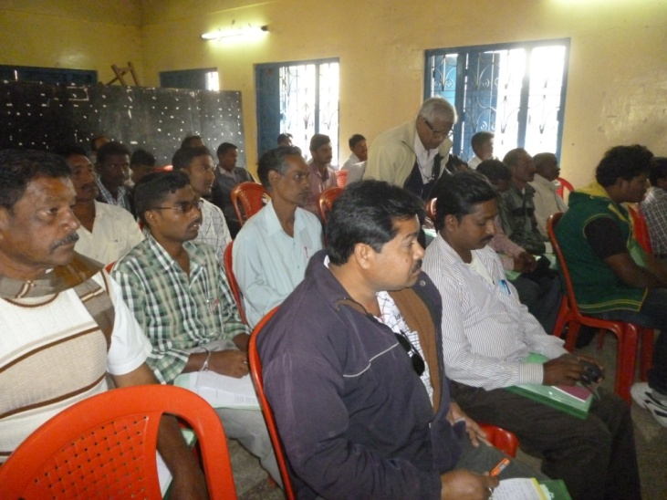
Financial inclusion, when promoted in the wider context of economic inclusion, can uplift financial conditions and improve the standards of lives of the poor and the disadvantaged. It could enable a disposable income in the hands of rural households leading to greater savings and a wider deposit base for banks and other financial institutions Thus, financial inclusion could be an instrument to provide monetary fuel for economic growth and is critical for achieving inclusive growth. Hence to participate in the process the organization RAJENDRA YUBAK SANGHA carried out 4 numbers of Workshops in different selected locations of Balangir & Bargarh District during the year under report in order to educate the people regarding the importance of financial literacy & financial inclusion and the procedure to involve in the schemes along with the scope & benefits such as Pradhanmantri Suraksha Bima Yojana, Pradhanmantri Jeevan Jyoti Bima Yojana, Atal pension scheme, Sukanya Samrudhi Yojana, use of rupe card, money transaction through mobile & Rupe & ATM Card etc under the schemes provided by the Govt.
ALLIED ACTIVITIES:
OBSERVATION OF R. N. SINGH DEO JAYANTI
King Rajendra Narayan Singh Deo & the Ex- Chief Minister of Odisha is one of the greatest & finest ruler of the State Odisha . He was one of the pioneers for the merge of the princely state in Union of India. He had an excellent personality and far above his contemporaries. His character & integrity constituted the foundation of his greatness. During his rein as King as well as Chief Minister he had dedicated much of his life for the welfare of the people. Impressed by the ideologies of the great soul R. N. Singhdeo the organization RAJENDRA YUBAK SANGHA came into being in the year 31st March 1991 and since then it has been observing the Jayanti of R. N. Singh Deo in order to remember his good work and spread his ideologies among the people of all walks of life. This year also the organization RYS observed the Jayanti on dt. 31-03-2018 in the premises of the organization and on the day chief guest invited to the meeting was none other than the grandson of Sj. R. N. Singh Deo Mr. Arkesh Singh Deo. During celebration of the Jayanti the organization some poor people were provided with clothes.
Promotion of Tribal Culture
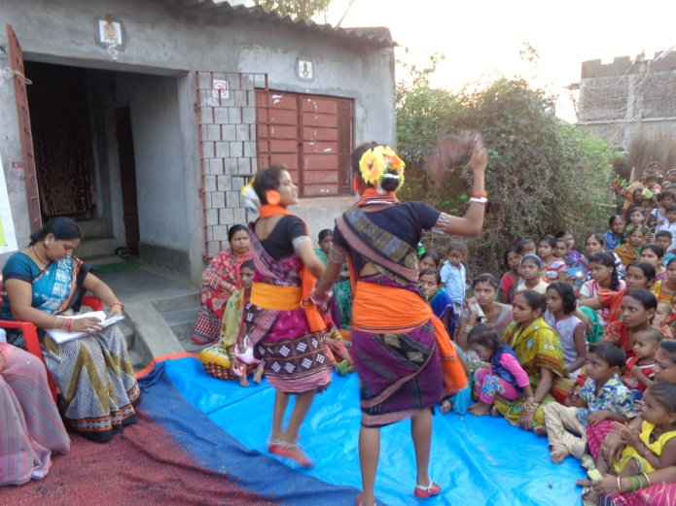
There has been an unprecedented rise in the electronics media which has affected adversely the traditional folk & tribal culture & cultural activities of different forms. To analyze the degradation of folk culture day by day the organization is trying to preserve the tradit ional music and art forms. In this connection for the promotion of folk and tribal culture the organization during the year under report organized workshop during February 2018 at Junhagarh of Kalahandi Dist. by inviting eminent researchers, folk and tribal artists, NGO personal carrying cultural activities and some activists to the workshop. In the workshop discussions were made on different folk & tribal culture & its causes of losing potentiality, probable steps to renovate the folk & tribal culture & measures to be taken to popularize & protect such unmatched folk and tribal culture.
MANAGEMENT OF OLD AGE HOME.
Realizing the miseries of older person in the area the organisation RAJENDRA YUBAK SANGHA initiated steps in this regard and started care of some older persons from its own endeavour and during the year under report at the Sripur, Sadar Block of Bhawanipatna, Dist,- Kalahandi for the older persons of the area by taking 10 numbers of destitute older people. In the home the poor older persons were provided with nutritional food, a well ventilated shelter and clothes check-up and recreational facilities along with their daily needs like soaps, ail and other cosmetics. Further they were also provided with psycho social counselling along with ensure physical, social, psychological and emotional support. Periodical health check by medical practitioner was arranged. To engage them in the canter so as to make them free from anxiety gardening, charchamandal, Bhajan etc are being organized from time to time. To carry out the activities in the Home an attendant cum peon is being engaged as paid worker. However to supervise the details activities of the Home the president & secretary of the organization act as honorary workers. To meet the details expenses the organization is completely depend on donations & fund raising activities of the organization.
Child Care Centre:
It is observed that there are some children who are physically challenged and are being neglected in the society. Further there are so many orphan children in the area. Hence to provide support & care to such children the organization RAJENDRA YUBAK SANGHA started a child care canter in the premises of the organization. Further the parents of the poor innocent disabled children were made aware regarding the beneficial scheme of Govt. for such children. During the year under report 5 numbers of children also tagged with the Govt. Programme. A growing numbers of orphan children are there in the area of operation of organization and they are leading a very pathetic life. Realizing the fact the organization carried out awareness activities in 3 villages under kantamal, jharbandh & Turekela Blocks for some prospective parents for adoption of such children by fulfilling the criteria.

Social Activities:
Like previous year during the reporting period the organization RAJENDRA YUBAK SANGHA also executed the following programmes and activities for the welfare of the target group.
- The organization identified orphan & destitute persons in the area who were in difficult circumstances and supplied foods and cloths to the identified person. Further some of them were tagged with the beneficial programmes of Govt.
- During the hot summer to provide drinking water facilities to the people on street the organization install a Jalchhatra at 3 numbers of places under Balangir Municipality for 3 months during April 16 to June 16.
- Some patients who are in need of treatment and want of financial supports were provided with some financial assistant by the organization RYS.
- Some poor students were identified in the area and they were provided with educational aid like note book, course book, compass box along with pen & pencil.
SPORTS AND GAMES:
The organization used to organize different sports activities & different tournament since its inception to increase the unity, integrity, fraternity and brotherhood among the players and for local talent search along with provide a good platform for the sports persons to exhibit their talent. The organization RYS like previous year organized following sports activities during the reporting period.
- The organization RAJENDRA YUBAK SANGHA organized one block level Foot Ball tournament involving 14 numbers of teams from the different parts of the district The football tournament was of 7 days duration. People of the block areas had come to view the games and encouraged the participants. The local community helps a lot in organizing the games and tournaments. The winner and the runners of the tournaments awarded with prizes and certificates. The tournament was taken place during Sept 17 at Railway station Playground.
- The organization RAJENDRA YUBAK SANGHA organized a Block level cricket tournament like previous year at Railway station Playground where 16 number of cricket teams from different part of the District attended. The tournament was of 15 days duration during Jan 18 at Railway station Playground. During the reporting session a number of eminent personalities were attended as guest to encourage the participants and members of the organization. Prizes and Gifts along with certificate of appreciations were awarded to the winner & runner and to the cricketer for their outstanding performances.
FUND RAISING ACTIVITIES:
Keeping in view of sustainable developments of the welfare activities of RYS the organization has stressed upon for developments of its own resources besides subscription and membership fees and except Govt. grant.
- Donation & Community Contribution
- Contribution from NGO/CBO members
- By organizing vocational Training & ASHA training
- By organizing cultural shows
- By Selling of seeds, plants & herbal products
- By organizing Football tournament.
- By organizing cultural activities
- Income from hire charges of training centre
- Income from the hire charges of LCD projector & Training equipments
- Income from sale of SHG & Craft products
- Income from social marketing of contraceptive.
- Income from mouse-jet machine.
Out of the above fund raising activities the organisation was received major financial support during the reporting year.
OBSERVANCE DAY:
The following National and important days were celebrated with much pump and grandeur during last year, competition like debate, Essay, drawing etc were organized during the days among students and youth. The observance days during the year.
- Environment Day
- Independence day
- Women’s’ Day
- Republic Day
- Gandhi & Shastri Jayanti
- R.N. Singh Deo Jayanti
- International Literacy day
- World health day
- Children’s Day
- World AIDS Day
- Youth day
- World T.B. Day
- Anti Tobacco Day
- Annual day of the organization

“RYS,IS WORKING OF THE PEOELE,FOR THE PEOELE, BY THE PEOELE”

Secretary,
Rajendra Yuvak Sangha(RYS)Balangir

