ANNUAL ACTIVITIES REPORT OF Rajendra yubak sangha (RYS)
FOR THE PERIOD 2016-17

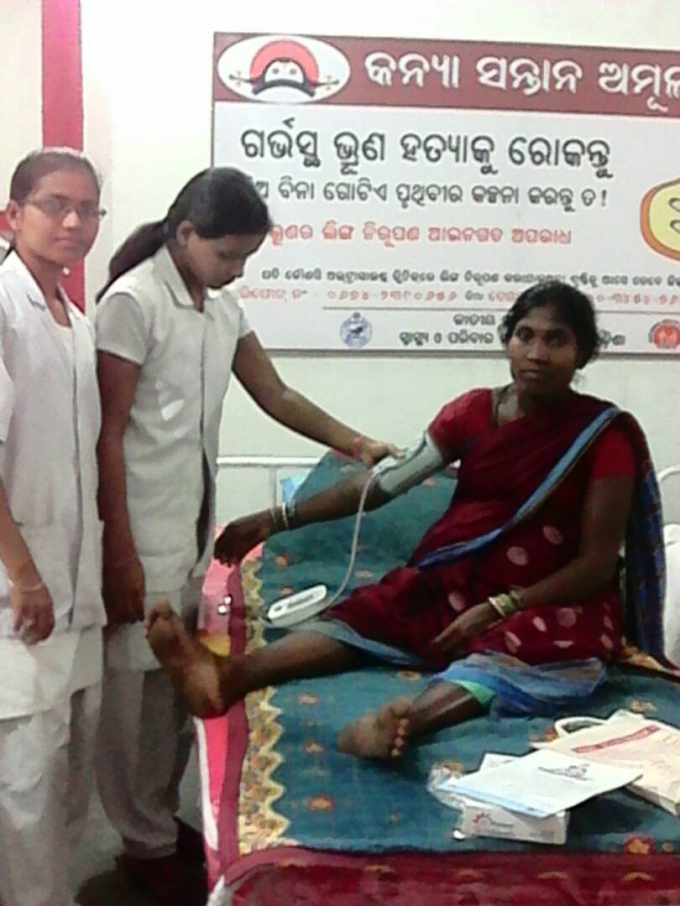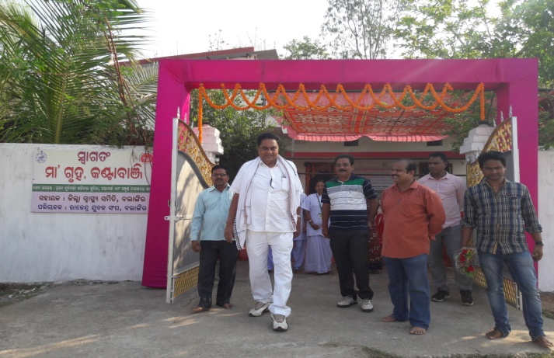
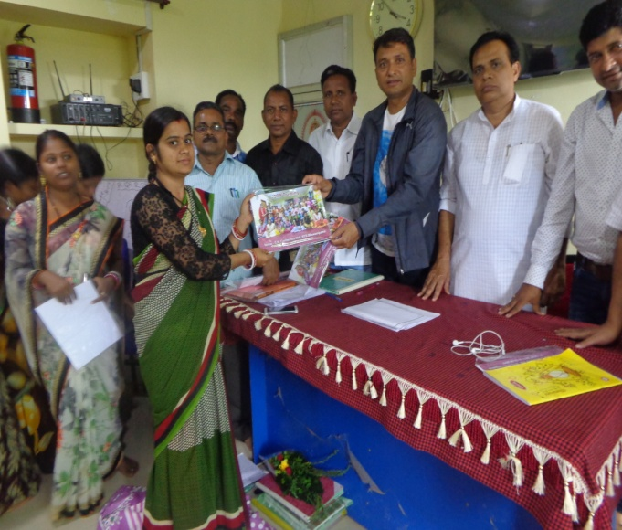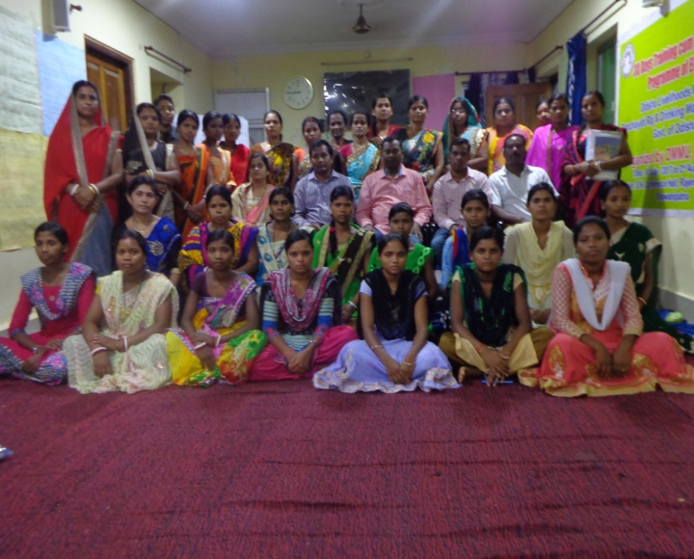
Address for Communication
At- Railway Station Road,
Po/Dist- Balangir, ODISHA- 767032

FORWARDS
Dear Friends!
Dear friends,
The year 2016-17 was remarkable and ever remembered year in the history of RAJENDRA YUBAK SANGHA (RYS). This Annual Report works like an effort road towards strengthening the activities of the organization in various roots and giving a new plan of action to RAJENDRA YUBAK SANGHA (RYS).

Since the beginning RAJENDRA YUBAK SANGHA (RYS) has been carried out various welfare activities for the improvement of the under privileged, socially and economically backward people ST, SC & the most vulnerable group women & child and the organization becomes out fit into a developmental organization.

During last session it has penetrated the programme on education, health, environment, child development, women empowerment and rural development.

We are happy to acknowledge our sincere and appreciation to all our Donors and Well-wishers for their continuous support, encouragement and assistance to make our aspiration and programmes a reality.

We also use this occasion to extend our hearties gratitude thanks to all our members, staff and collaborators in the field and thousand of well – wishers for their kind support and involvement.

I extend my heartfelt thanks to the community women groups and volunteers who have participated actively in different activities of the organization for its successful achievement.
With regards to all.
Secretary, RYS

PROGRAMME AND ACHIEVEMENT REPORT OF RAJENDRA YUBAK SANGHA (RYS)
FOR the period 2016-17
PROGRAMME SUPPORTED BY GOVT INSTITUTION
During the year under report the organization has carried out a numbers of activities under Health related issues and challenges by the support of different Govt. institutions in order to increase the health status of the people in need. The Programme includes, TI under HIV/ AIDS for the IDU, Pehechan for MSM & TG Hinjda & ASHA training.
Training of ASHA:
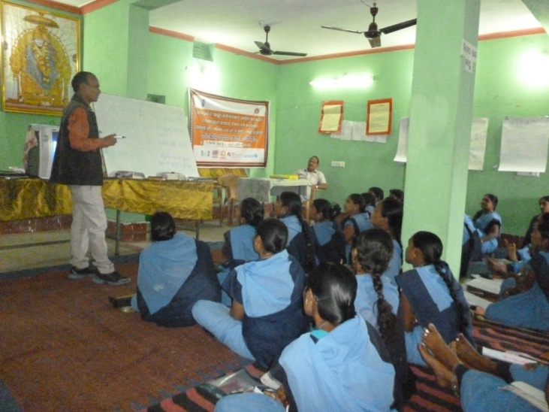
One of the most important responsibilities to fulfil the objectives of NRHM has been given to the ASHA. She is the driver of the programme in village level for executing different activities under NRHM by emphasizing the Janani Surakha Yojana and has done excellent in this connection. So for the better execution & implementation of the programme of NRHM the ASHA should be trained & capacitate regarding the plan & procedure with implementation & execution of different health related activities and the Health administration has also given priority for the same and executed a numbers of training programmes for the ASHA. However during the year under report by the extensive support and guidance of the District health administration Balangir & Bargarh the organization RYS conducted training of ASHA of Agalpur, Balangir, Gudvela & Loisingha under Balangir District and Atabira, Sohela, Bhatli, Bheden & Bargarh under Bargarh District.on 6th and 7th modules.
TI Project for Injecting Drug User:
Due to unemployment, distress migration, over ambitious, high need, modernization, urbanization and industrialization it is observed that use of drugs among the youth has been increased to a greater extent and the drug users create havocs in the society. The IDU are excited & tempted after taking drugs and they become very dangerous & harmful and at that time they do not hesitate to do any sorts of crime without thinking any consequences of the crime. Further the drugs have been life killing at times and Injecting drug users are at high risk

so far infection of HIV/AIDS is concerned. So in order to reduce such harms, happenings & effects of the IDU the organization RYS oriented the high risk group on the details of the adverse effect of the drugs not only on their personal health status but also put an adverse effect on the society. Further the target groups were also educated regarding the acts and the prevailing judicial procedures of different harms the IDU do. the activity was organized by RYS in the operational villages of Bargarh District during the year under report. However the programme was supported by OSACS BBSR and to reduce the risk the organization RYS has taken the following steps
- Condom promotion and social marketing
- Harm reduction through motivation and mobilization.
- Awareness and sensitization for drug de-addiction
- Discourage needle exchange and use of unsterilized syringe.
- Abscess management
- Role of ICTC and Govt. Facilities for the victims
However the identified drug users were provided support and care along with motivation and linkages for reduction, management and control of HIV/AIDS.
Community Process activities:
The preamble to the constitution of the World Health Organization states that “the enjoyment of the highest attainable standard of health is one of the fundamental rights of every human being without distinction of race, religion, But due to lack of proper health education, ignorance, shame and poverty, the rural people are deprived of his facilities at their door step. As a result a number of people die without having any preventive knowledge or precautionary measures. So to aware the people of different unnerved villages under block a numbers of awareness programmes covering more than 15000 belong to slum population under Balangir Municipality through meetings, rallies, distribution of IEC material, leaflets and exhibition of posters etc were organized by RYS, these activities direct impact on the people and they were educated about different health problems and they became access to the facilities being provided by local PHC. Activities was undertaken by the own resources of the organization. Under these programme the following activities were being in force.
- Strengthening and operationalization of Mahila Arogya Samity
- Strengthening ASHA activities & strengthening to ASHA
- Supervise the Immunization & UHND programme

- Formation & Functionalization of RKS
- Facilitate the slum meeting & provide hand holding support to the mass
- Vulnerability assessment in slum areas of Balangir Municipality to collect the health related information from the slum people.
- Resource mapping in the slum areas.
- Formation & orientation of Ward Kalyan Samity thyrough IEC & BCC
Management /Maintenance of Urban PHC:
Following the successful take-off in both rural and urban areas Public Private Partnership (PPP) in the Health Sector of Odisha has been used as an appropriate technology for proper implementation of the programme and to achieve the goal in an objective directed way. It has widened the scope for meaningful collaboration of the key players engaged in healthcare and service delivery including in the Government run Health System. In this connection the organization RYS is entrusted to carry out the management & maintenance of Urban PHC at Kandhpali under Balangir Municipality. Under the programme the following services were provided
- OPD Consultation
- Weekly Specialist service
- Free Medicine as per the Govt. EPD
- Diagnostic service like pathology test on malaria, dengue, Hemoglobin, urin albumin, and sugar, RPR test for syphilis and blood grouping and Rh typing etc.
Drug De-addiction Centre:
In the district of Balangir there are growing numbers of drug users especially in the slum and its nearby areas and many times they used to harm people and suffer from their health status. So looking & realizing the situation & having experience in the field and in order to reduce the harm and adverse effect of Drugs & IDU the organization RYS by its own effort established a Drug De-addiction Centre (DDC) near the office premises of the organization RYS on the railway station road. In the DDC 17 numbers of drug users of the area were enrolled in the centre and they were provided education about different acts relating to different crimes. The inmates of the DDC were warned about the adverse effect of drugs and about the risk factors in mode of transmission of HIV by using unsterilized syringes. The drug users were discouraged to take drugs and they used to provide activities like T.V., Video, indoor games organized song & dance competitions from time to time for their recreation. Some case studies have also been discussed with them to make them

refrain from this illegal practice. To carryout different activities a counsellor and a community organizer were engaged. However the staff of the organization also supported the activities at the time of need.
EDUCATION:
It has been rightly said “Education is the modification of human behaviour. Further for the progress of the country as well as for the progress human mass education is the basic need for every individual, as it is the manifestation of all round development. Nevertheless, most of the tribal pockets in Odisha are at a far distance from getting minimum level of learning. Hence, the govt. has putting in Herculean efforts for enhancement of the educational and literacy status of the people and is putting Herculean effort for the same. But due to some factors the same has not yet been achieved to a mark level. There are still some areas with a number of non-literate people along with number of dropout and non-starters. Hence, on the wake of such a situation the organization RYS had taken the following steps during the reporting session for the enhancement of Education and Literacy Standard of the people.
Free Coaching Centre:
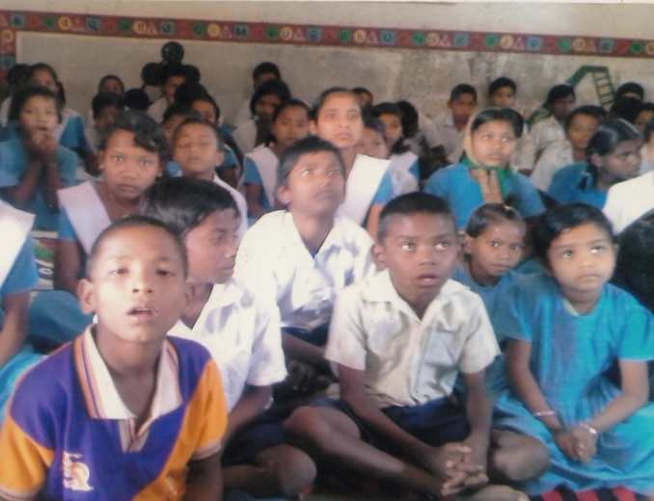
Most of the people of Muribahal & Turekela Block belong to ST category. Many of them are Landlessness and small land holding among the poor households do not provide any opportunity to increase their farm income. The organization felt that with the bounty of natural around, their lies much opportunity for the poor to increase their income once they are imparted the necessary skill and education. Working in the tribal dominated areas where education is not at all prioritized believes that education is the only means of development of the ST people & their socio-economic condition can be expected better with this believe the organization gives more emphasis in promotion of ST education in its operational area. Further in this context to make the ST students to cope with the present education system the organization RYS provided education on the class course to the ST students on free of cost. Besides this the organization in the process organized meetings for the parents for promotion of the education of the ST students. It is seen that many time the poor ST students do not able to

Purchase their course book and in spite of their interest for study they are being dropped out from the school. So the organization RYS realizing the fact and for the better and higher education of such students initiated steps and in this context it has distributes text book and course book to the needy 35 numbers of High school students of the local High Schools during the year under report.
Digital Literacy & Awareness:
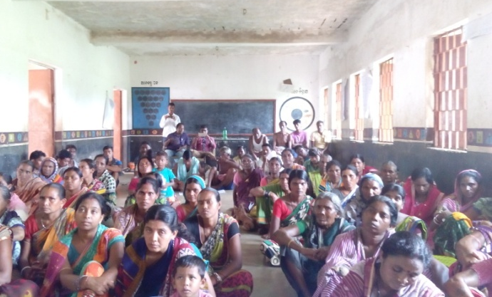
There is rampant ignorance in the district of Balangir. As a result a lot of atrocities are committed against the disadvantaged sections of the society including SCs, STs and women. It is the age of digital era. The Govt. has given much emphasis on digital activities starting from information technology to money transaction. But it is seen that most of the people even educated people are not aware of digital literacy. So to aware, educate & motivate the people regarding the digital literacy the organization RYS arranged 30 numbers of awareness activities in different villages of the Balangir district & some part of Bargarh district. Prior awaring the people the organization orient some youth volunteers of the district regarding digital literacy and its scope and activities & beneficial aspects. In the awareness meeting the following points were emphasized.
Library & Mobile Library Service:
Library is this social institution offering information dissemination services based upon knowledge for various groups on Social, Political, Economic and other matters, This also a common man’s cultural centre for those who have in mind their recreational role and information centre for some others. Also it is a gate way to knowledge; provide a basic condition for Life-long learning, Independent decision making and cultural development of the individual as well as develop thy social well being of the groups. The organization established library units of its own in the promises of its registered office at Railway station Road Balangir. The library is well equipped with thousand numbers of different varieties of books comprising of Literature, historical; mythological , health and hygiene, child care and other developmental books and many others books. Besides some indoor games colour T.V have been provided for the entertainment of the reader. The readers are children,

Adolescents, farmer, women, student, educated youth and general public of the locality. The library has created & strengthens reading skills of children from an early age, promoted awareness of cultural heritage appreciation of this arts, scientific achievements and innovations. To fulfil the need of different categories of readers including the neo literate the institutional library is having reference books, text books, literature, mythological and historical books, magazine, booklets, newspaper, journal etc. Some indoor games like carom, chess, chains checker etc are also play in the library centre. Especially youth and students of the area availed the opportunity of the library during the reporting session. Further a mobile library is also function under the organization and a staff is engaged to carry out the activities under the mobile library.
HEALTH :
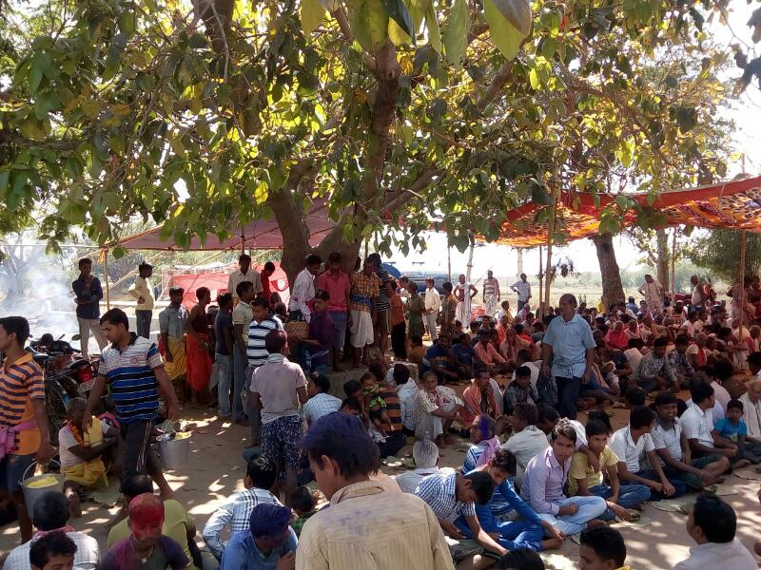
It is but a fact that a sound mind always followed by a sound health and the soundness of health can only be achieved by keeping the health in proper condition through various ways and means. The Govt has given more and more emphasis to primary health care but the bitter part is that the health care facilities are yet to be reached to the remote parts, for which the people of this part of the world suffer a lot in their health aspects every time. Inspite of the Herculean effort of the Govt. to ameliorate the health status of the people, most of the programmers can’t be rendered into reality. The reasons are the lack of initiative apathy and lack of knowledge of the beneficiaries, poor infrastructure and carelessness of the line department. So in the wake of such an atmosphere the organization RYS executed the following activities in its operational area.
Malaria & Dengue Control programme
Among various diseases Malaria & Dengue are now at its peak by taking a numbers of lives. Malaria & Dengue are serious and many times life killing disease & there are instances of much more malaria deaths in rural pockets. In view of the above it was very important to create a positive and inspiring environment among the rural people to fight against Malaria & Dengue through adopting different preventive & curative measurers. To ensuring community participation and support of PRI members regarding issues related to

malaria & Dengue the organization RYS organized 23 numbers of awareness camps at Balangir, Puintala & Loisingha Block and 3 numbers of camps under Balangir municipality. In the camps discussions were made on the causes & symptoms of Malaria & dengue it’s, prevention & control, Health-related facilities provided by Govt. the roles and responsibilities of PRI members in health programmes were discussed in detail. In the camps the participants urged to clean the house hold & village surrounding along with water bodies, encouraged for use of impregnated bed nets. Avail free health services for PHC/CHC during fever, testing of blood during fever and early treatment.
Sensitization on HIV / AIDS:
At the present juncture HIV/AIDS have become the most dreaded disease and is spreading very fast into the human world. The tribal areas of the state are also not immune from its grip. As far as the present level of knowledge is concerned there is no such curative medicine for it. The only way out is to prevent it. Thus, has tried its level best to make the people conscious to prevent this dreaded disease through awareness creation. In this Endeavour, various rallies, community meetings and street plays were organized by the organization on World Aids Day on 1st December this year. The volunteers of the organization RYS have conducted a series of meetings during the year under report with the most vulnerable groups like; youth and migrant labours, High risk group, FSW, MSM & TGH at different places in and around Balangir & Bargarh District and made them aware about this ghastly disease of AIDS. In the awareness camp organized at different villages people were urged by volunteers to follow different preventive methods during their sex activities to save themselves from the spread of HIV. Sensitizing the seriousness of the situation, SSSS has also started some integrated effort to diminish the impact of this dreaded hazard. Further the Adolescent group of different parts of Balangir were educated regarding the issues and challenges relating to HIV/AIDS along with its preventive measures and in this connection the organization RYS organized 4 numbers of orientation camp on ARSH and HIV / AIDS during Sept. 16.
Awareness on T.B.:
It is observed that there is a rapid growth in the population of urban slum dwellers. Despite the supposed proximity the urban poor to urban health facilities, their access to health services is limited due to inadequate public health delivery system. Due to poor environmental conditions along with high population density the slum dwellers more

vulnerable to Tuberculosis. Hence with a view to aware such people the organization RYS arranged 15 no’s of awareness camps in the urban slum areas of Balangir municipality & Balangir Block during Nov. 16 to Jan. 17. In the camps the people of the area were educated on the following topics.
- Causes and symptom of T.B
- Information regarding pending migration.
- Schemes of health administrations
- Regarding the role of D O T provides
- Details of curative aspects and treatments process
- About RNTCP and referral/services
Yoga Sibir
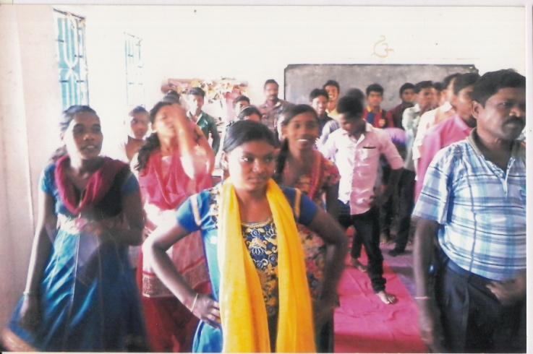
The purpose of yoga education is not only to impart knowledge but more importantly to tap the hidden talents and potentialities of the people and helping them to develop physically, intellectually, morally and spiritually. It can help in the task of providing holistic education and keeping the body and mind in sound condition. Keeping in this view of the benefit of yoga and naturopathy the organization RYS has celebrated the international Yoga Day at District level in the office premises of the organization on dt. 21st June 2016. In the camp the expert Guru was invited and he was imparted training as well as conducted practical forms on Yoga for the benefit of the participants. However the activity was attended by 100 numbers of participants
Blood Donation Camp:
Blood donation is a noble work as it helps a lot of people who are in need of blood during their health related problems. It is seen that a numbers of people die due to want of Blood and many times some rare blood groups are not available in the blood bank. So with a view to sensitize and encouraged the youth the organization conducted a sensitization meeting on Blood donation and on the day a Blood donation camp was also organized at at

Sai Temple under Balangir Town By the consent of the participants the organization RYS keep the name of the participants along with their blood group & phone numbers so that they will be informed as the time of need of blood for patients.
Diabeties Camp:
Due to lack of information, unawareness & poor initiative apathy the people of the area of operation of RYS are used to suffer from diabetics problems and they do not able to take treatment as they do not identified their suffering and many people die due to the adverse effect of diabetic. Hence realizing the fact the organization RYS carried out 3 numbers of diabetic testing camp at Urban PHC Kandhpali by inviting the medical professionals. The experts attended the camps provided tips as well as medicine for the same.
Cancer Screening Camp:
Cancer is a serious & life killing disease. Cancer occurs due to taking of intoxication, gutka, tobacco, alcohol, cigarette, bidi drugs, tambakhu etc. due to cancer the effected people lead very pathetic life and it is observed that such types of patients are neglected & much time hatred by the community. Further the people are completely unaware about the causes of cancer. Hence to aware the people on the said disease the organization RYS conducted 5 numbers of sensitization meeting in different locations of Balangir & Patnagarh Block. Further a cancer screening camp was also organized at Urban PHC Kandhpali during .
WOMEN EMPOWERMENT :
“The hands that rock the cradle can rule the world”. This saying always instils a sense of inspiration among the women mass. But in this age old and so called made dominated society wards and phrases like women education women development etc have become bookish. Empowerment of women is the major thrust area of every country. With out the development of women, the development of the society and the country as a whole is beyond expectation. So empowerment of the women socially, economically and educationally is one of the greatest area concerns of the Government today. Inspite of several programmes the quantitative and qualitative improvement is not yet possible to a mark level. So with a view to provide them support services for their improvement and empowerment the following activities were taken up by the organization RYS for the upliftment of the women.

Promotion & strengthening of SHG:-
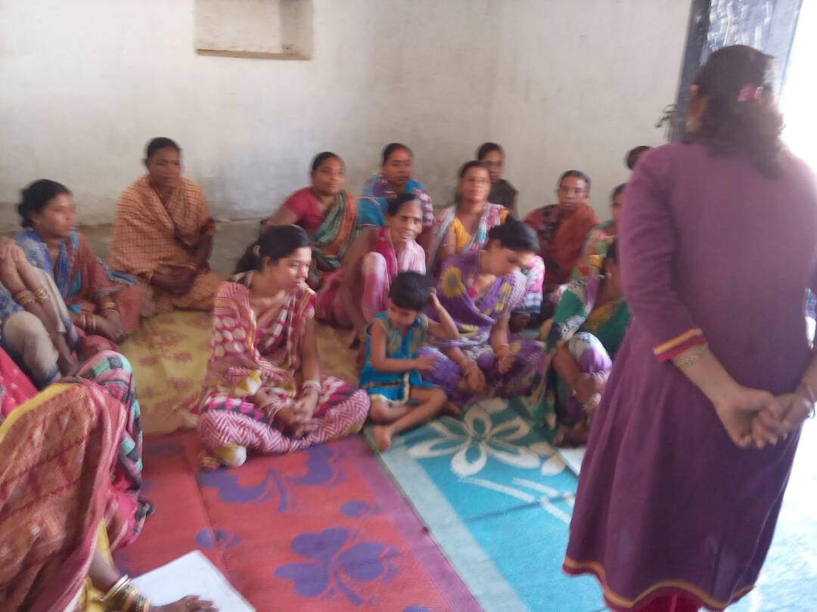
Women’s empowerment is an important agenda in development efforts. The organization RYS aims at empowering women through formation and promotion of women’s s elf help groups. During the year under report the organization RYS formed 15 nos SHG. Training was provided for 2 days duration as induction training for maintenance of the SHG in some villages of its operational area during Jan. & Feb 17. The organization made efforts to tie up some of the active WSHGs with in local financial institution and pursued for financial assistance on the basis of their actual performances to meet the requirement for production and marketing.
Income Generation Programme:
The organization RYS is putting much importance on training programme of SHG members by which the later can be active participants in the process of sustainable development. The basic objective of RYS is being executed vocational skill development training & thus such types of trainings become an inseparable but critical part of the organization activities. The organization RYS during the year under report for sustainable socio economical development of the said SHG groups and in this connection carried out the following training to develop their vocational skill.

Fodder cultivation:
With a view to enhance the economical status of the SHG members the organization RYS conducted a training camp on fodder cultivation at Bubel G.P. of Puintala Block during the reporting session. In the training near about 25 SHG leaders of the area were trained on the technique of cultivation of fodder. To train the group the expert of the locality as well from out sides were invited as RP.

Training on Phenyl Making:
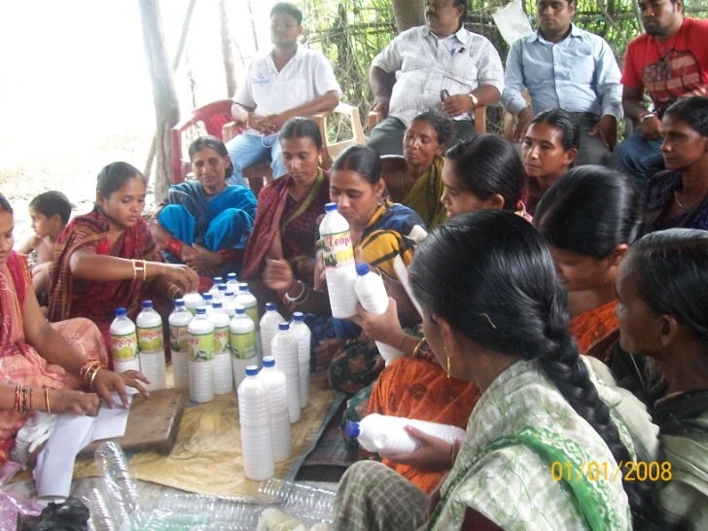
The organization RYS like previous year under took activities to enhance the skill and competencies of the youth on different suitable vocations. In this connection during the reporting period the organization arranged training at Jagua of Titilagarh block. The training camp was based on small and petty business like phenyl making. In the training 22 numbers of youth were benefited. To train the group on the trades MCM on the said vocations were engaged. However to market their products the organizations people were also taking initiatives.
Training on Rice Processing:
The livelihood system of the poor people of the operational area of the organization RYS is very alarming. Looking to the situation the organization RYS from its own effort provided revolving funds to two numbers of SHG & undertook skill development training on rice processing for the poor SHG members to provide them income generating option for their sustainable livelihood. The partnership of the organization RYS and the beneficiaries brought outstanding achievement so far benefit aspect of the poor is concerned.

Financial Support to CBOs:
The richness of the society is known by the respect that it gives to its people. The livelihood system of the poor people of the operational area of the Association RYS is very alarming. Looking to the situation the Association RYS by its own effort supported financial assistance to the CBOs promoted by the organization RYS among the MSM, IDU & PLHIV & MTH in order to provide them livelihood option so that they will start their individual business on some suitable vocations. Further the CBS were trained under the vocations like Poultry Farming, Goat Farming, Vegetable Vending & other petty business. However the following CBOS were being supported under the programme

- Lxminarayan MSM CBO
- Maamanikeswari MSM CBO
- Help Trust for PLHIV & MTH
- Dhanwantari Baidya Sangha
- ASTHA IDU CBO
The partnership of the Association RYS and the CBOs brought outstanding achievement so far benefit aspect of the members of the CBOs.
Capacity Building Training of SHG & CRP
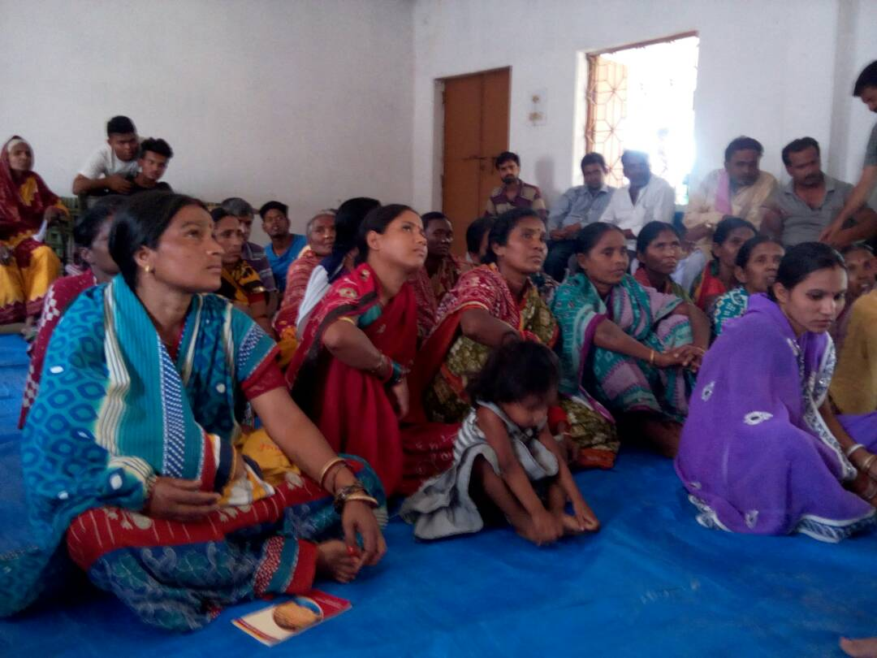
For the sustainability of the SHG & CRP groups & in order to built the capacity of the members to mobilize and management of the groups during the reporting period the organization RYS conducted 4 numbers of training at Bhawanipatna under Kalahandi District supported by OLM. In the camp resource persons from different field like women and child development, ICDS, Bank professionals, NGO etc. were invited to the camp to discuss and impart training on the following topics.
- Formation & Mobilization of group
- Group management
- Role of members & leaders
- Resource tapping.
- Type of records to be kept
- Procedure to maintain different records
This training was organized during the year under report. However 136 numbers of SHG members were trained on the topics.
ENVIRONMENT AND PLANTATION:
For the survival of all the living being environment has got an important place. But it is a matter of regret that inspite of major area of concern of the Govt. to keep the environment in a proper condition, due to factors like unconsciousness and unawareness at peoples level population explosion poor infrastructure facilities and many more the environmental situation has been degraded to a greater extent and reached to an alarming condition. Such a situation is causing a number of problems in the ecology sector which in turns put an adverse effect on

human health hygiene and economy sector as well. So with a view to make a study and make the people of its operational area aware regarding the above situation and to get rid of the situation the organization RYS coming with some following efforts during the reporting session.
Program on Plantation:
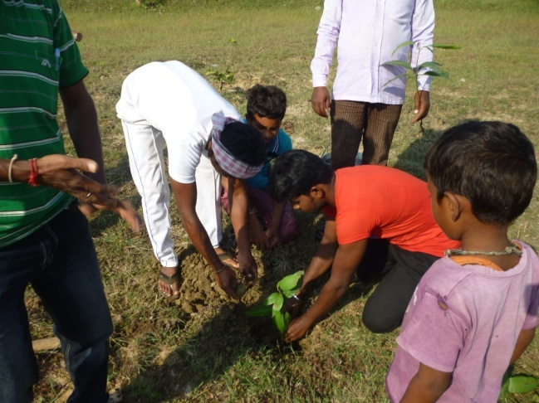
Most of our populations particularly the illiterates and those who are living in tribal areas are not aware about the consequences of slashing the trees near human habitation. Even most of our civil society members like, PRI Members, Youth Club Members, women SHGs do not understand the gravity of the fact. Hence the organization RYS carried out some awareness cum action activities to make the group aware intensively on the issues and en couraged them for plantation. Further the organization RYS also initiated steps for plantation of different fruit bearing and herbal plant along with plant like Akashia, Bamboo, Harida, Bahada, Tik Mango etc which were planted in 1 acres of land by the organization near Siletpada of Puintala Block.
Nursery & Seedling:
Thousands hectors of waste lands and high lands are lying unutilized in some areas of Patnagarh blocks under the area of operation of the organisation. However the organization RYS raised a nursery of 50,000 seedlings of different species of mixed verities at Bileisath. The nursery comprises of Horticultural, Fruit bearing & Medicinal plants. The farmers were supplied with the species at nominal cost for promotion of agro forestry and farm forestry.
Seeds & Herbal Products:
From the very ancient period the knowledge herbal, medicinal and Aromatic plants (Banasaudhi) were in much demand. But unfortunately people are getting far away from this life saving herbal products and the ancient knowledge could not proceed forward due to emergence of Allopathic system of medicine, though the use of medicinal and aromatic
plants was there for treatment purpose but without any documentary evidence it has lose its potentiality and demand. But now the same is in much demand for use of medicinal and aromatic plants by all developing countries and as such the overall trade of crude medicinal and aromatic plants is about seven billion dollars and is on increase at the rate of 7% per

annum. Keeping in view of the crucial linkage between common diseases of rural communities with medicinal & herbal plants available in the locality the organization RYS promoted herbal seeds for plantation & use of herbal products to use as medicine for different diseases. The organization also prepared some herbal products by the experts and sold to the individual with a very nominal price. The promotional activities educated the rural community to access to the herbal practice.
skill development training under vedant foundation
During the year under report the organization RYS by the support of Vedant Foundation, Mumbai carried out the following skill development training camps in its area of operation.
Computer Training
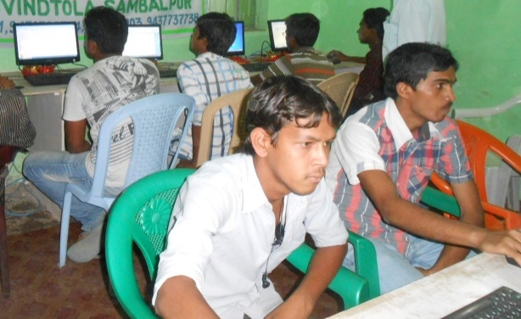
Computer education is at the present era is one of the important section not only in public sector but also in private sectors. Persons having computer course are preferred in the job market. Keeping in view of the unemployment problems among the educated mass in rural areas, and realizing the unaffordable capacity for computer education of the students/ parents the organization RYS initiated steps to provide computer education to the interested students with a very nominal price and in this connection during the year under report the organisation RYS started computer training centre at different locations of Balangir Town, Tusra under Gudevela Block, KIantabanjui & Titilagarh NAC. During the year 12 numbers of training were organized by covering 300 numbers of educated Youth. To impart the technique on basis operation and computer application one expert instructor in the field was engaged. Free computer education is one of the measure tasks of the Trust. Hence it has a plan to execute the programmes in many locations for the educated youth students in the coming years.
Tailoring Training
For the economic empowerment of women RYS had organized Skill development trainings in its operational area at Barapudugia, Jhankarpali, Bagbadi & Talpalipada in the district of Bolangir to provided training on suitable income generation activities to the interested youth girl. However during the reporting session the organisation conducted a training camp for the Youth girl on. Experts and experience Trainer were engaged to train

the trainees. Further the participants were also provided knowledge on marketing of the above products. The organisation has taken initiatives to sell the products. Further the trainees were also trained on the topics like Packaging, costing & Marketing techniques, Customers dealing & marketing exposure and advertisement and Publicity
Mobile Repairing Training:
Mobile repairing now a day’s is cent percent income generating vocation as maximum numbers of people now use mobile. During the reporting session some Youth who have interest in the trade like mobile repairing were identified and enrolled in mobile repairing training were admitted in the training centre at Sohela of Bargarh District & Balangir Town in the training the trainees were provided different technique on the course including modern and improved tools and machineries used in mobile repairing. 60 numbers of youth were trained during the year under report.
AWARENESS PROGRAMME:
Awareness on Waste Management:
Piles of garbage in the villages have not only a damaging bearing upon the beautification of the village but also have put worst impact on human health and hygiene. It is observed that people are so callous even they do not hesitate to deposit the waste here and there. Hence the people should be educated on the management of solid waste in a sustainable way to overcome and minimize the ecological imbalance and environmental degradation to greater extent as well as provides income generating option on the other hand by producing Bio Compost out of the biodegradable solid waste. The people of this part are also completely unconscious about these negative effects of solid waste. So understanding the gravity RYS organized awareness camp at 4 locations of Balangir & Subarnapur District during the year under report. However the following points were also emphasized.

- Dustbin had been promoted among the People of the area.
- Students were demonstrated on management of school waste and preparation and use of school dustbin.
- Demonstration on construction compost pit was also done in the area.

Swachh Bharat Abhijan:
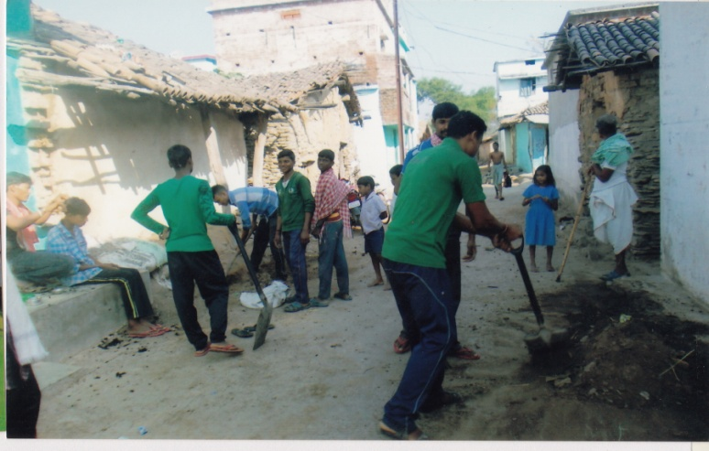
In order to make the rural people sensitized on use of safe drinking water & to keep proper sanitation organization RYS has been taking keen interest to educate the people for proper sanitation & water management and care of personal hygiene by the support of the volunteers and staff. The programme was taken up in 32 numbers villages of Puintala, Balangir, Loisingha & Deogaon block under Balangir District and the volunteers and staff of the organization RYS along with some NGO activists educated the villagers on proper sanitation Water management technique & Management & recycle of waste, cleanliness, plantation, personal hygiene etc. However the villagers were encouraged for installation of IHHL & encouraged for development of community compost pit. During the process some community compost pits were constructed in some villages by the help of the community. Further the BPL families were tagged with the R.W.S.S for installation of IHHL.
- Defection in the open is caused ill health use of Sanitary Latrine advisable
- Prevent breeding of flies by safe disposal of garbage
- Using of hand pump or tap water for drinking and domestic purpose
- Wash hands with soap after defection
- To increase peoples knowledge of important sanitation issues
- Cleaning of water bodies

AWARENESS ON PMVKY:
Pradhan Mantir Kaushal Vikash Yojana (PMKVY) is the flagship outcome-based skill training scheme of the new Ministry of skill development & entrepreneurship (MSDE).The objective of this skill certification and reward scheme is to enable and mobilize a large number of Indian youth to take up outcome based skill training and become employable and earn their livelihood. However to aware the Youth regarding the benefit under the scheme PMKVY, monetary reward would be provided to trainees who are successfully trained, assessed and certified in skill courses run by affiliated training providers the

organization RYS conducted 3 numbers of awareness activities in Komna & Khariar under Nuapada Dsitrict during the reporting period.

Awareness on DDUGKY:
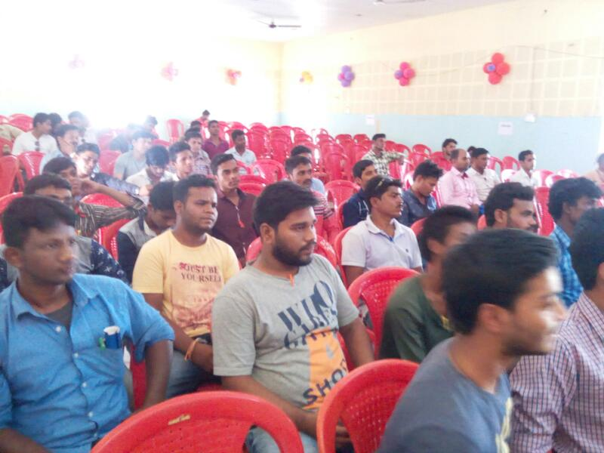
For the sustainable livelihood of the youth the organization RGSERC used to organize training programme for skill development the group on different suitable vacation the organization RYS is putting much importance on training programme of different category of youth by which the later can be active participants in the process of sustainable development. To manage their affairs without any substantial outside support, the organization can transfer the management skill to the community. However to aware the people regarding the programme Din Dayal Upadhyaya Gramin Koshal Vikash Yojant (DDUGKY) the organization conducted 8 numbers of awareness activities in patnagarh, belpada, Balangir & Puintala Block of Balangir District and 2 numbers in Bhawanipatna under Kalahandi District during the reporting period.

Awareness on Road Safety
Due to increase in population, urbanization, the so called fast & advanced world, modernization and luxury life of people the numbers of vehicles on the road is increased more than the expectation. To control and avoid accidents the Govt. has promulgated the traffic rules which is violated many times and thus accidents occur large in number by taking a numbers of lives and injured innumerable. It is observed that due to Lack of good road sense unaware of traffic rules. Jumping signals and not knowing what lane driving means, always results in accidents. Further other major causes for road accidents are speeding beyond the limits inside the town area; Drunken driving, overtaking dangerously
etc. so to aware people on the above mentioned problems to avoid accidents the organization RYS organized rallies in 3 locations of Balangir District during celebration of road safety week.

Youth Development
Youth is the main power in every society. A good numbers of youths having academic qualification are found unemployed and sitting idle. The organization RYS was having Target to utilize the power of the youths in a constructive way and created field for them in extending helping hands for strengthening their knowledge and skill. However the following activities were taken by mobilizing the youth during the period under report.

Entrepreneurship Development Programme. (EDP):-
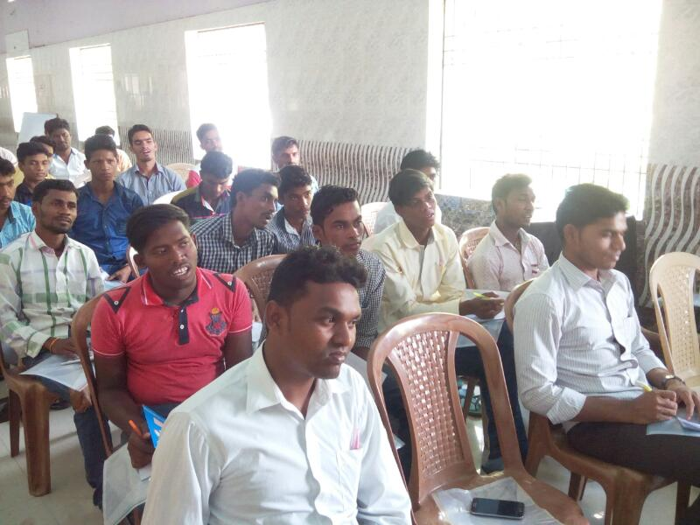
During the reporting session the organization extended its intervention towards EDP in the rural areas especially for the rural farmers of its operational area. The main objectives of the programme is to train the rural youth farmers on processing and preservation of seasonal fruits , vegetables for the growth of agriculture as well as for the economic development of the beneficiaries along with establish effective integration and synergy between agriculture and agro based industries. However in this context the organization carried out 3 nos of EDP training at Puintala & Loisingha Block under Balangir district & U;unda under Subarnapur District. On all the 3 camps 78 numbers of beneficiaries were being trained by the experts in the field. In the camp the following points
- What is entrepreneurs
- How to develop a business
- Marketing quality control study, linkages and exposure
- How to deal with the consumer
- The procedure of packing
- Costing & record keeping
- Preparation of project report & Financial linkages

Leadership Development
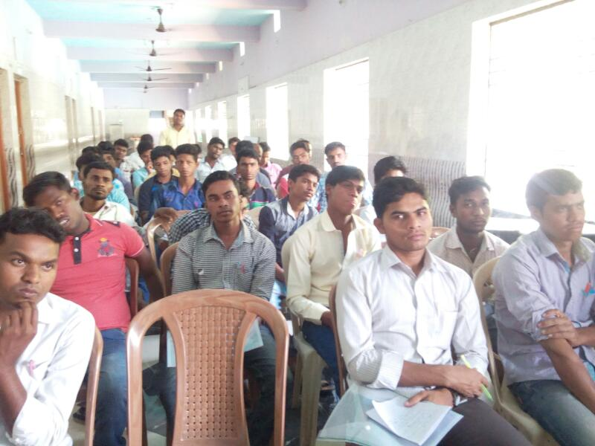
The organization RYS was having target in extending helping hands for promotion of youth activities by developing of their leadership quality. During the reporting session organized 2 numbers of training camps Bahtli under Bargarh District & Saintala under Balangir District by involving 127 numbers of youth from different CBO like youth club and voluntary organization. The wells experienced RPs from different Govt. department as well as from NGO were invited to the camp to provide guidance and impart training to strengthen their leadership & create enthusiasm among the youth regarding their roles & responsibilities towards the society. Further they were encouraged to take up different welfare activities in the areas for the overall well being of the community people.
AGRICULTURAL ACTIVITIES:
The major earning activities in the rural pocket is agriculture where people are involved to earn their livelihood to maintain their family and it is directly linked with sustenance of rural economy of the poor community. The area of operation of the organization RYS is rain fed area and is completely under the deadly cause of draught. Due to various factors such as low rain fall, adoption of traditional method for cultivation lack of knowledge information and training on improve technology, use of old method, lack of convergence and networking, lack of initiative apathy etc. have lead to low productivity and straight away affect the economy of the poor farmers which in turns bring them health hazards, mal nutrition, at times starvation. Hence realizing the facts the organization RYS executed different activities for promotion and extension of agriculture in the area during the year under report.
Mushroom Cultivation:
For the sustainable economic development of the farmers & SHG members the organization RYS conducted 2 numbers of training camps on mushroom cultivation at Lefta of Puintala Block & Dashimal of Gudvela Block in Balangir District during the reporting session. In the

training near about 45 farmers & SHG leaders of the area were trained on the technique of cultivation of mushroom of different types. To train the group the expert of the locality as well from out sides were invited as RP. Further the trainees were also provided quality control, packaging, costumer dealing and marketing of mushroom. This business provided ample scope for the SHG & farmers to enhance their economy sector.
Promotion of Producer Group:
Although agriculture contribute to GDP is hovering around 15 %, it provides employment to 56 % of the Indian workforce. The growth of some commercial crops has significant potential for promoting exports of agricultural commodities and bringing about faster development of agro based industries. Agriculture not only contributes the overall growth of economy but also reduce poverty by providing employment and food security to major part of India. The milieu of the Endeavour is growth of agriculture and allied sector and economic prosperity of rural farmers and establishes effective integration and synergy between agriculture and agro-based industries. Again there have been no appropriate technological interventions to play role for better output and reduce the drudgery of the rural farmers. Hence at this situation promotion of federation among the farmers or Farmers Producer Organization (FPO) will certainly provide ample scope for the farmers to address their problems in an objective directed manner to increase the socio-economic status of the farmers. So realizing the fact the organization conducted 4 numbers of sensitization programmes during the year under report for promotion of Farmer’s Producer Group.
Maize Cultivation:
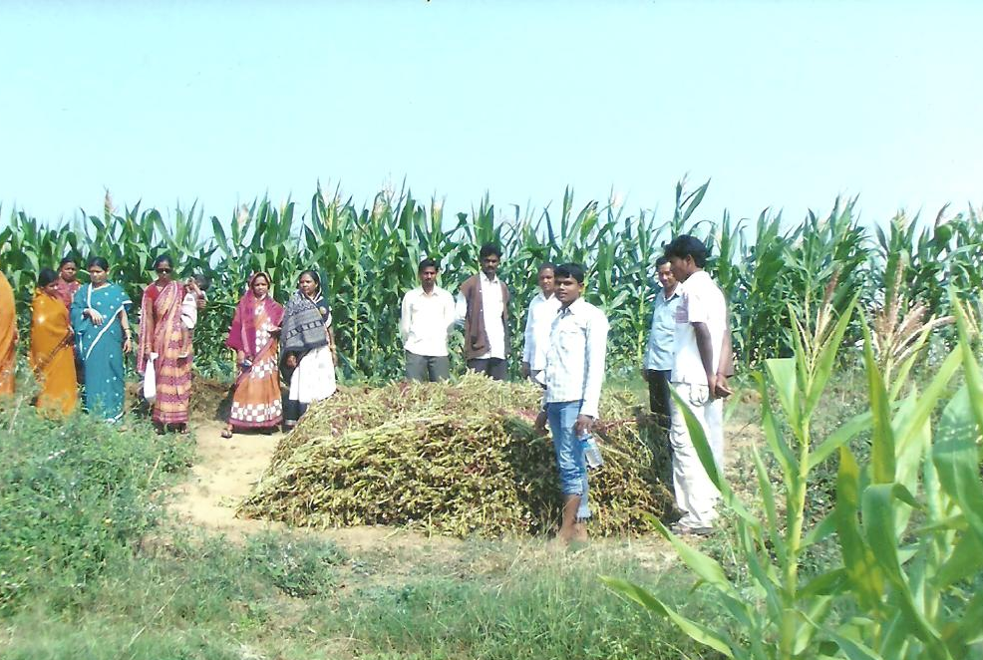
During the year under report the organization RYS has taken a lead role in bringing up the condition of the farmers in the operational area by the support and guidance of ATMA Balangir under RKVY the RYS has taken up activities under the scheme RKVY and promoted, popularized & extended the following activities. Promote and popularize hybrid maze among the farmers.

Orientation on Vermin Compost:
Due to use of chemical fertilizer in the cultivable land, the land losing its fertility day by day which straight away effect the agricultural production? Hence the organization RYS arranged 3 numbers of orientation camps for the small and marginal farmers of Loisingha & Gudvela Block. In the orientation camp the participants were oriented by the expert on preparation of Bio – Compost and vermin compost. Further the participants are encouraged to use Bio Fertilizer in place of Chemical to keep the humus content of the land and its fertility. The activity was taken up during June & July 16.
ART & CULTURE:
If we look into the pages of history we can find that art and culture have been the sole source of entertainment & inspite of the uniqueness of different culture & art form there are some similarities which bind the entire country under the fold of unity. Subsequently such entertainment has engendered get togetherness as well as unity in the forms of societies, groups and ultimately National Integration but such an unmatched contribution has totally been forgotten under the monstrous spell of westernization, western & Bollywood. Our pristine and sacred culture of folk art, songs and above all dance are dying out rapidly and our cultural world is being deserted. Looking to this situation in order to promote & popularize the dying art form the organization RYS carried out the following activities during the year under report in its operational area.
Promotion of Tribal Culture
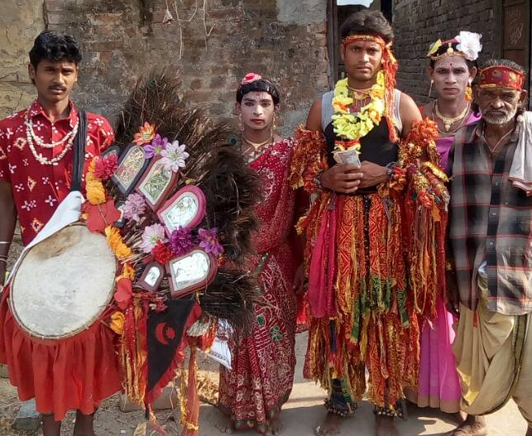
There has been an unprecedented rise in the electronics media which has affected adversely the traditional folk & tribal culture & cultural activities of different forms. To analyze the degradation of folk culture day by day the organization is trying to preserve the traditional music and art forms. In this connection for the promotion of folk and tribal culture the organization RYS during the year under report organized workshop at Patharla of Puintala Blcok during January 2017 by inviting eminent
researchers, folk and tribal artists, NGO personal carrying cultural activities and some activists to the workshop. In the workshop discussions were made on different folk & tribal

culture & its causes of losing potentiality, probable steps to renovate the folk & tribal culture & measures to be taken to popularize & protect such unmatched folk and tribal culture.
R.N. Singh Deo Jayanti:
A politician of complete ability & a resourceful, lovable & approachable person King Rajendra Narayan Singh Deo & the Ex- Chief Minister of Odisha is one of the greatest & finest ruler of the State Odisha . He was one of the pioneers for the merge of the princely state in Union of India. He had an excellent personality and far above his contemporaries. His character & integrity constituted the foundation of his greatness. During the year 1967 he became the chief minister of Odisha and had done lots of development works for the people as well as for the area. So to commemorate the great personality and to spread the ideologies of Honourable late Rajendra Narayan Singh deo the organization RYS celebrate the 106th Jayanti of Rajendra Narayan Singh deo on dt. 31.03.2017 in the premises of the organization RYS at Railway Station Road, Balangir. On the day competitions on song, debatge, quiz etc were being conducted agog the students of school and colleges of Balangir Town
District level Workshop on Financial Literacy & Inclusion:
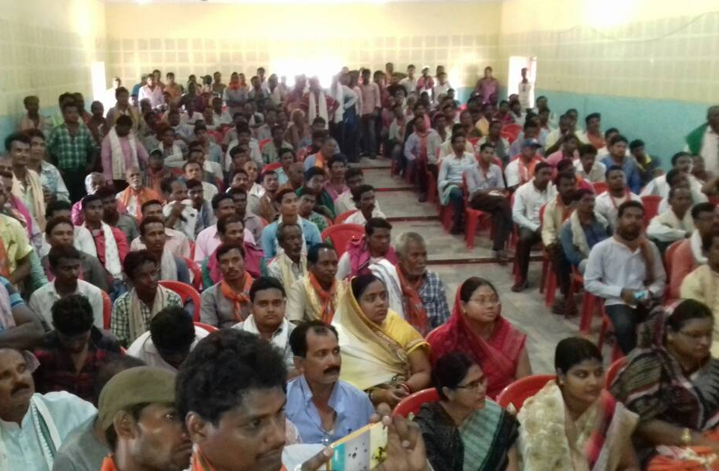
Financial inclusion, when promoted in the wider context of economic inclusion, can uplift financial conditions and improve the standards of lives of the poor and the disadvantaged. It could enable a higher disposable income in the hands of rural households leading to greater savings and a wider deposit base for banks and other financial institutions Thus, financial inclusion could be an instrument to provide monetary fuel for economic growth and is critical for achieving inclusive growth. Hence to participate in the process the organization RYS carried out 12 numbers of awareness meetings in different selected locations of Tarbha Block under Subarnapur District & Puintala, Balangir & Deogaon Block under Balangir District during the year under report in
order to educate the people regarding the importance of financial literacy & financial inclusion and the procedure to involve in the schemes along with the scope & benefits such

as insurance benefit like JYBY, SBY, Atal Pension scheme, sukanya Samrudhhi yojana etc under the schemes provided by the Govt.
MANAGEMENT OF OLD AGE HOME.
Among the total population nearly 28% belong to the old aged ones i.e. above 60 years of age and nearly 10% of them are still neglected, who are struggling for better nutrition, health care, social status and facing psychological problems. Hence realizing the urgency the organisation RYS also initiated steps in this regard and started care of some older persons from its own endeavour in its operational area. However the poor older persons were provided with food, and clothes along with psycho social counselling. To execute the details activities & to meet the details expenses the organization RYS is completely depend its fund raising activities.
Care of Disabled Children :
It is observed that there are some children who are physically challenged and are being neglected in the society. However to sensitize the people as well as parents of the area of operation the organization RYS arranged an assessment camp at Gudighat under Muribahal Block. The parents of the poor innocent disabled children were made aware regarding the beneficial scheme of Govt. for such children. During the year under report 5 numbers of children also tagged with the Govt. Programme. In the camps the people were also aware as how to deal with such children for their care & development.
Social Activities:
Like previous year during the reporting period the organization RYS also executed the following programmes and activities for the welfare of the target group.
- A growing numbers of orphan children are there in the area of operation of organization and they are leading a very pathetic life. Realizing the fact the organization carried out awareness activities in 3 villages under Belpada & Khaprakhol Block for some prospective parents for adoption of such children by

fulfilling the criteria. The organization identified orphan in the area who were in different circumstances and supplied foods and cloths to the children. Further some of them were tagged with the beneficial programmes of Govt.
- During the hot summer to provide drinking water facilities to the people on street the organization install a Jalchhatra at 3 numbers of places under Balangir Municipality for 3 months during April 16 to June 16.

- Some patients who are in need of treatment and want of financial supports were provided with some financial assistant by the organization RYS. However 3 nos. of patients who are in serious condition were partly supported for treatment at Burla. Besides the above the organization helps a numbers of patients in getting proper treatment in the head quarters Hospital at Balangir
- Some poor students were identified in the area and they were provided with educational aid like note book, course book, compass box along with pen & pencil.
SPORTS AND GAMES :
The organization used to organize different sports activities & different tournament since its inception to increase the unity, integrity, fraternity and brotherhood among the players and for local talent search along with provide a good platform for the sports persons to exhibit their talent. The organization RYS like previous year organized following sports activities during the reporting period.
Football Tournament
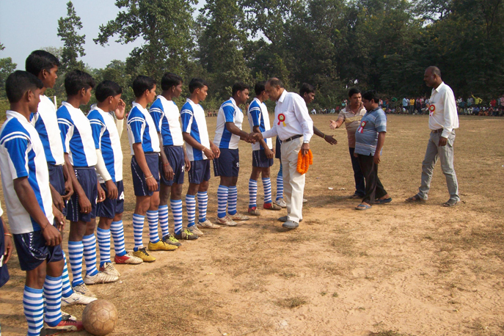
The organization RYS organized one block level Foot Ball tournament involving 14 numbers of teams from the different parts of the block Balangir The football tournament was of 7 days duration. People of the block areas had come to view the games and encouraged the participants. The local community helps a lot in
organizing the games and tournaments. The winner and the runners of the tournaments awarded with prizes and certificates.
Cricket Tournament:The organization RYS organized a Block level cricket tournament like previous year at Railway Station Field under Balangir Town where 16 number of cricket teams from different part of Balangir District attended. The tournament was of 15 days duration during Jan 17. During the reporting session a number of eminent personalities were attended as guest to encourage the participants and members of the organization. Prizes and Gifts along with certificate of appreciations were awarded to the winner & runner and to the cricketer for their outstanding performances.

OBSERVANCE DAY:
National and important days were celebrated with much pump and grandeur during last year, competition like debate, Essay, drawing etc were organized during the days among students and youth.
