ANNUAL ACTIVITIES REPORT OF RAJENDRA yubak sangha (RYS)
FOR THE YEAR 2015-16

The organization also supported the activities at the time of need.
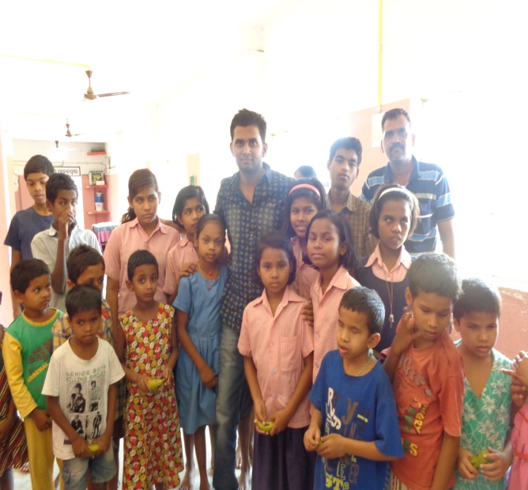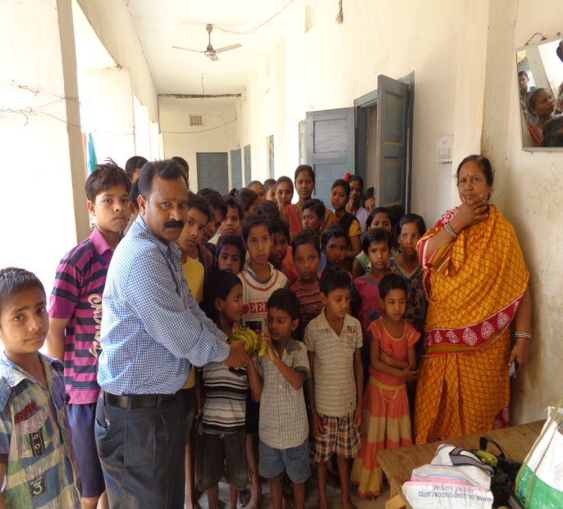
Address for Communication
At- Railway Station Road,Near FCI.Godown.
Po/Dist- Balangir, ODISHA- 767001
Phone-06652-234547,Mob-9853200783,9178805084
Email-rajendrayuvak.sangha@rediffmail.com,rys.bgh@gmail.com
Web site:www.rys.org.in

FORWARDS
Dear Friends !
RYS has come into being in the year 1991 and is progressing with a multiplicity of experiences inducting different categories of people with different interventions. In its journey to achieve the goal the main emphasis has always been given to the community participation & ownership by taking the people’s strength. The long cherished dream came true when it got its legal affiliation during the year 1993

RYS is committed to provide a platform to the people belong to deprived, downtrodden and underprivileged irrespective of caste, creed and colour for their development and empowerment. Initiating number of activities this year, RYS prioritized the activities in the field of socio-economic development as a whole and women empowerment along with activities on health, education and environment with a focus on improvement in quality of life of the people.

RYS believes in sustainable development through participatory approach and advocacy for the community. In its journey, the management of RYS has taken up the challenge to empower the tribal people for their socio-economic development and to reduce sufferings in every sector of their life.

RYS has tried a little bit to bring out this consolidated volume of “Annual Report” of organisation for the year 2015-2016 and welcome feedbacks from all of our well-wishers surrounding us.

Confident on continuing fruitful relations, we would like to take this opportunity to thank all of our donors, well-wishers, volunteers, supporting organizations and community people of our operational areas who are standing with us as our source of inspiration and the target of our work and effort.
Thanks.
Secretary, RYS
OPERATIONAL AREAS OF RYS:
Sl. No | District | No of Sub-district covered | No of GPs covered
1 | Balangir | 14 | 142
2 | Sonepur | 2 | 8
3 | Bargarh | 10 | 82
4 | Kalahandi | 4 | 20
5 | Nuapara | 3 | 16
Total | 5 | 37 | 277

The activities of RYS were primarily focused in Total area --- GP-277 Villages - 1655 Nos. Block- 37 Nos. District- 5 the organization RYS has been able to expand the activities to different parts of the western belt of Odisha stronger in the field of rural development Let us come together and join our hands to make all economically backward KBK districts. Besides, RYS is also expanding the horizon to operate its various extension programs on emerging critical issues surrounding the society with vulnerability.
TARGET GROUP
Through the organization works for all the sections of the society the following groups of people are regarded as special target groups by the organization.
- Small & Marginal Farmers.
- SCs, STs, and OBCs
- Migrant Labour
- Women and Children
- Rural Artisans
- Youths and Adolescents
- Vulnerable Group

FOCUS INTERVENTIONS:
RYS is more concentrated to provide better livelihood options as its interventions are largely focused in the socially and economically backward areas of the district. In addition, the organization also provides intellectual and technical inputs to the people at large in the following sectors of development to implement the programs effectively and efficiently:
- Integrated rural development programs.
- Promotion & popularization of Agricultural activities.
- Sustainable livelihood & Natural Resource Management.
- Promotion of Education & Literacy in the area.
- Women empowerment through formation & management of Self Help Groups.
- Orientation & capacity building programs for different stakeholders on different interventions.
- Sensitization programs on safe drinking water, proper sanitation and best hygiene practice.
- Community health programs on eradication of malaria, HIV/AIDS, reduction of IMR & MMR, immunization & RCH.
- Development of ST/SC, Youth & Children
- Promotion of Sports & Culture
Activities
- Community Health care
- Promotion of Education
- Livelihood Promotion
- Community based Institution development
- Capacity Building Initiative
- Networking & Advocacy Grassroots level
Services
- Care and support for Marginal Grups,MTH &PLHIV.
- Information for legal and social security Scheme.
- Non-formal Education & library
- Counselling Camp with Mobile health Service
- Livelihood / Income generation / Skill development training
F. Medicinal Plant service Programme & Collection of Herbal Product &
Nursery Rising.
G.Drug De-Addiction Centre for Drugs User .

ACTIVITIES OF RAJENDRA YUBAK SANGHA (RYS) DURING THE YEAR 2015-16
During the reporting the organization undertook several programmes for reaching the objectives of the organization. While implementing the projects care was taken to put more emphasis on the process of empowerment so that they can take the development agenda further. During the reporting period the organization has undertaken the several programmes for the target group.

HEALTH
Care of Disabled Children:
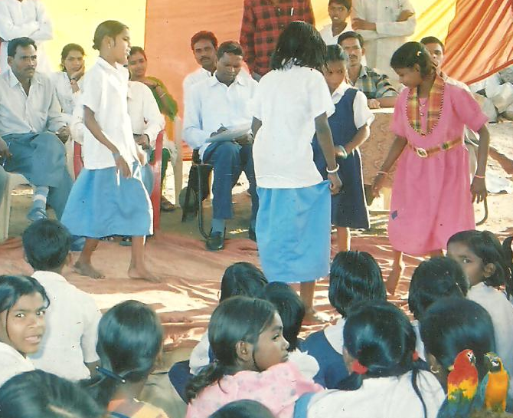
If we think about the disabled children they have not been benefited to a mark level in all most all the sectors. More specifically in rural and remote pockets of Odisha the promotion of health amo ng the rural mass has been given prime importance in last one decade, but special euphonies yet to be given in a targeted way to provide qualitative and complete health development to disabled children. There is a need in integration of such children at present. It is observed that there are some children who are physically challenged in the area of operation of the organization RYS and are being neglected in the society. In order to encourage and aware the identified parents of disabled children for better health care of their disabled children the parents are being counselled and are being motivated at their doorstep through training education and orientation. However to do the educate the parents experts were invited as R.P. further the organization also arranged a sports activities for the physically challenged students at Tarbha under Subarnapur Block
Health Care Centre:
One of the prime activities of the organization RYS is to provide health services especially to the poor and to provide free health check up with free medicine the organization has established a health care centre in the office premises where Free Health Check-up is being provided along with medicine on nominal for the needy. A good number of patients of different age-group and different categories were came to the health care centre and were examined by the part time medical officer and provided with medicine as per the availability after proper diagnosis. Some patients in serious condition were referred to the Hqrs Hospital. A part time & a full time doctors along with staff nurse are being engaged in the centre.
Mobile Health Service:
Though our Govt. has implemented a numbers of programmes to address the issues of the people related to health problems the same has yet to be universalized due to the factors like poor initiative apathy, carelessness, negligence etc. And it is observed that the people of some remote concern are still debarred from getting different health services. In order to address the issues and to provide health service at the door step of the people in need the organization arranged mobile health service in Balangir, Subarnapur & Bargarh District during the year and extended health services to a numbers of people. The endeavour of the organization has been warmly accepted by the people as well as the rationale one.
Health Care & Support:
It is observed during different FGD & one to one interaction with the high risk group including FSW, MSM & IDU that the Person leaving with HIV/AIDS are being neglected by the society in spite of all sorts of awareness given to the community. Without having any care or support their health status has been deteriorating to a greater extent. Hence realizing the fact the organization RYS used to provide care & support to such group through its counsellor & outreach worker and at times tagging them to the health administration. Under these programme a numbers of MSM & Tran gender Hinjda who are the most vulnerable groups are also being supported.
2.day-Dist. Level Workshop on Social Security schemes for PLHA & MTH
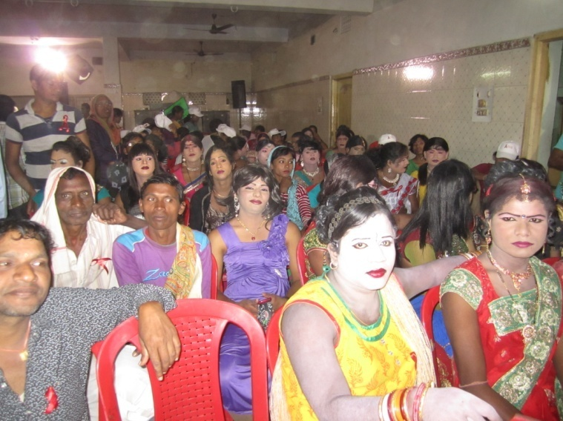
Our Govt has been implementing a numbers of programmes and schemes for the people in need for their survival. Accordingly the Govt. has implemented Social Security schemes for the PLHA & MTH. But the same has yet to be universalized to a mark level because of lack of information & knowledge among the target group. In order to provide the group identified the area about the proper information & benefit of the Govt. the Association RYS organized 3 numbers of workshops at Balangir, Subarnapur & bargarh district during the year under report to sensitize the people of the area regarding information and benefit of different beneficial schemes of Govt. Some of these programmes that have been emphasized & discussed in the camps were SGSY, IAY, Madhubabu Pension, Antadaya Anna Yojana, Annapurna Yojana, Rural Public distribution system, care & support for PLHA & MTH etc. Further some IEC materials on the above programmes were collected and distributed among the participants.

HEALTH AWARENESS PROGRAMME:
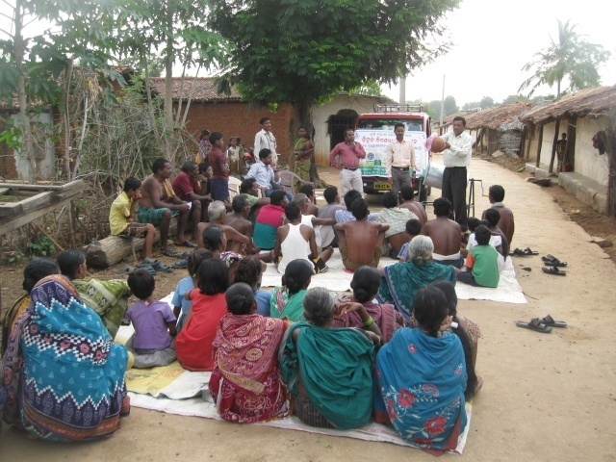
The preamble to the constitution of the World Health Organization states that “the enjoyment of the highest attainable standard of health is one of the fundamental rights of every human being without distinction of race, religion, But due to lack of proper health education, ignorance, shame and poverty, the rural people are deprived of his facilities at their door step. As a result a number of people die without having any preventive knowledge or precautionary measures. So to aware the peop le of different unserved villages under Balangir & Subarnapur District the organization conducted 25 numbers of awareness programmes covering a numbers of population through meetings, rallies, distribution of IEC material, leaflets and exhibition of posters etc these activities direct impact on the people and they were educated about different health problems and they became access to the facilities being provided by local PHC. Activities was undertaken by the own resources of the organization.
01. Activities organized during the year are.
- During the Health awareness camp which was organized at 5 villages of Balangir & Loisingha Block during Nov. 15, the participants were provided knowledge on curative and preventive measures of some common ailments.
- Awareness camps were organized on malaria & Dengue in 6 numbers of villages of Balangir & Gudvela Block where the villagers were aware on the cause. Preventive and curative aspect of malaria. IEC materials were also distributed among them.
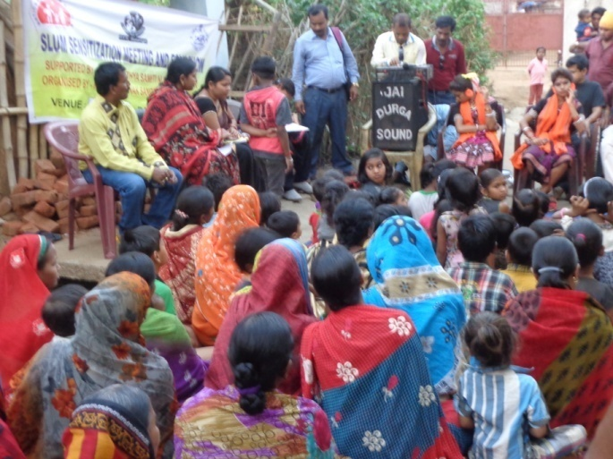
- The organization carried out 4 numbers of activities at different locations of Balngir & Bargarh Municipality to aware the migrant & youth regarding the causes and symptoms of HIV/AIDS, its mode of transmission along with prevention & control.
- Organized 4 awareness camps on Jaundice in bargarh District to educate the people on the adverse effect of Jaundice and its preventive measures and curative aspects. During the activities the people were also motivated to avail the opportunity by the Govt. Health Administration.
- To aware the poor people on the issues, causes, prevention and curative measures relating to T.B. the organization RYS during the reporting session carried out 5 numbers of activities in 5 villages of Deogaon & Saintala Block of Balangir District where the people were aware and educate on the following points.
Besides the above the organization also arranged 10 numbers of rallies in the above areas to motivate & mobilize the people for better health status.
02. Awareness on Jaundice:
The rapid growth in the population of urban slum dwellers has created a havoc in health sectors. Despite the supposed proximity the urban poor to urban health facilities, their access to health services is limited due to inadequate public health delivery system. Due to poor unhygienic environment, taking of steal food the slum dwellers & people of remote habitation are more vulnerable to Jaundice. Hence with a view to aware the people on the causes, symptoms, prevention & curative measures of the diseases the organization RYS arranged 5 no’s of awareness camps in the urban slum areas of Balangir municipality & Titilagarh NAC of Balangir District during the year under report.
03. PEHCHAN PROJECT ON HIV/AIDS FOR MTHs
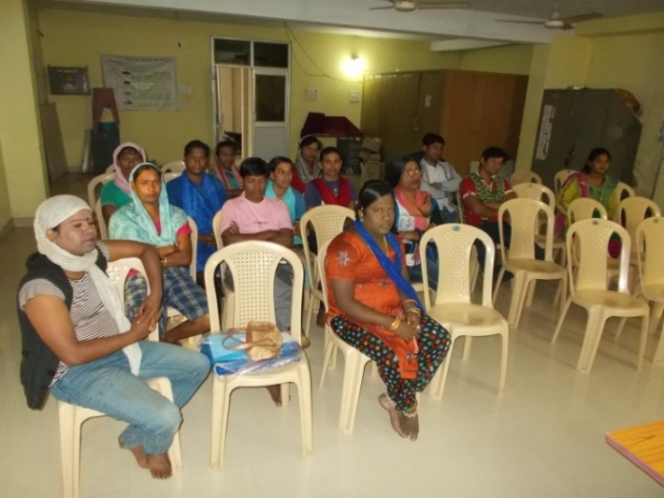
The studies have revealed that PLHAs among Hinjra are not free from discrimination, gender disparity and unequal treatment to HIV +ve, venial of services and treatment by the Doctors of Govt. a nd Private clinic. It is but necessary to counsel the MTH group through human rights approach that can go a long way in removing the stigma & discrimination attaching to them and better orient the society towards their problems. So to give them identity (Pehchan) the organization RYS has been implementing project Pehechan for the MSM, TG Hinjda in the entire Balangir district. Under the project the organization executed the following activities.

Counselling through One to one & focus group discussion with the client group i.e. MTG Hinjra to address the problems being faced by hijra/ transgender such as fear, shame, gender, social pressure, depression, suicidal tendencies, social stigma, etc."

Again the community was also mobilized not to avoid or hate such person rather help & support such people.
- Educate them & ensure same sex & same rights for them under article 377.
- Provided them support under incentives & Govt. facilities as meant for them.
- Made linkages with STI clinic, ICTC & ART centre for preventive measures
- Vocational skill development training for self employment of the group
- Arranged health insurance for them & Prepared I card for them to get facilities of Govt.
- Ensure their participation in developmental process.
Besides the above the group were being provided knowledge on HIV/AIDS, STI/RTI, safe sex practice, use of condom, testing of blood, scope & activities of govt. for the PLHA.
Orientation Prog. On Harm Reduction:
It is observed that after taking drugs the IDU are excited & tempted in a numbers of cases and they become very dangerous & harmful and at that time they do not hesitate to do any sorts of crime with out hesitation. Further it is also observed that if they do not get money for the drugs they also never hasitate for doing crime with out thinking any consequences of the crime. So in order to reduce such harms, happenings & effects the organization RYS oriented the high risk group on the details of the adverse effect of the drugs not only in health but also in the society. Further the target groups were also educated regarding the acts and the prevailing judicial procedures of different harms the IDU do. the activity was organized by RYS in the operational villages of Bargarh District during the year under report.
Tergated Intervention for Injecting Drug User (IDU):
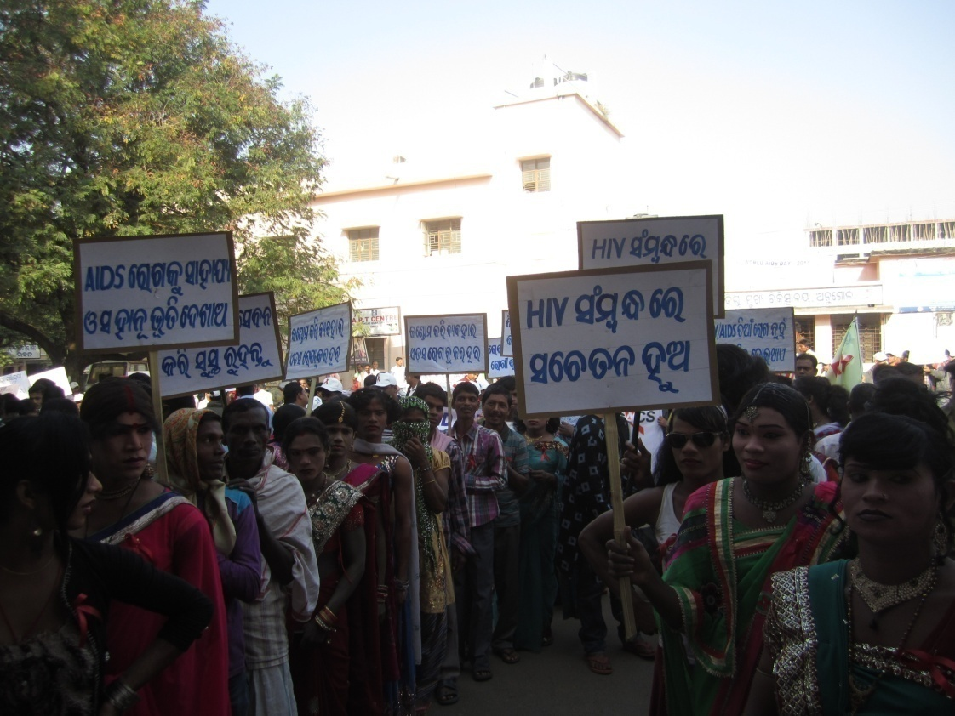
For the last 8 years the organization RYS by the support of OSACS under the TI Project interven in the area Atabira, Sohela, Padampur, Paikmal and Jharbandh Block under Bargarh District in the state ofgrowing numbers of drugs users are there in the district of Bargarh in the state of Odisha in order to control & prevent HIV/AIDS among the Drug Users. In the area of operation there are a growing numbers of drug users & the rate is higher among the youth. Many times due to use of unsafe & unsterilized needles during inject of drugs through vain many times the intervenous drug users are at high risk so far infection of HIV/AIDS is concerned. Under these programme the organization has taken the following activities during the year under report in the assigned areas.
- Aware on adverse and deadly effect of intravenous drug use.
- Discouraged the high risk & other people for use of Drugs
- Harm reduction through motivation and mobilization.
- Awareness and sensitization for drug de-addiction
- Discourage needle exchange and use of unsterilized syringe.
- Abscess management
- Condom promotion and social marketing
- Causes and symptoms of STI/ RTI & HIV/AIDS.
- Role of ICTC and Govt. Facilities for the victims
- ART treatment & Promote referral services.
However the identified drug users were provided support and care along with motivation and linkages for reduction, management and control of HIV/AIDS. A big rally was taken during World AIDS DAY by the active participation of the Target groups.

Drug De-addiction Centre:
The organization having a lots of experience in dealing with the drug users to prevent them from the deadly effect of HIV infection as well as take necessary initiatives for reduction of harm among the IDU. In this connection the organization RYS carried out TI project in Bargarh district. During pilot survey in the district of Balangir the organization observed that in this district also there are growing numbers of drug users especially in the slum areas and its near by areas the numbers of drug users is very high and many times they used to harm people. So looking & realizing the situation & having experience in the field the organization RYS by its own effort established a Drug De-addiction Centre (DDC) near the office premises of the organization RYS on the railway station road. In the DDC 15 numbers of drug users of the area were enrolled in the centre and they were provided the following services.
- The inmates of the DDC were warned about the adverse effect of drugs and about the risk factors in mode of transmission of HIV by using unsterilized syringes.
- The crimes that the drug users usually take during the time of intoxication and different acts relating to different crimes.
- The drug users were discouraged to take drugs and they used to provide activities like T.V., Video, indoor games organized song & dance competitions from time to time for their recreation.
- Some case studies have also been discussed with them to make them refrain from this illegal practice.
To carryout different activities a counsellor and a community organizer were engaged. However the staff of the organization also supported the activities at the time of need.
AWARENESS camp ON CHILD RIGHTs & PC PNDT Act.
Declining numbers of girls in the population as per 2011 census indicates that the child sex ratio is adverse for girls and this could lead to a serious cultural problems and population imbalance in India. Further the high member of missing girls is indicative of the poor status of the girl’s child and women. The common reasons of the low levels of sex ration are son preference, neglect of the girl child, high mortality rate of girl child, female feticide and maternal morality. However the main reasons are the practice of sex selection before delivery. So to overcome the problem the Govt. has enforced the P.C – PNDT Act since 1994. But with having any information or knowledge the same has been violating to a greater extent. Hence to make the people, civil society members, NGO activities eligible couple of the area the organization MSWO arranged 5 numbers of awareness activities on PC & PNDT Act 1994 in 3 villages of Puintala Block and slum area of Bolangir Municipality during the reporting session. Experts on the topic were invited from Bolangir as R.P to deliver their lecture on the topic.
yoga & Naturopathy camp
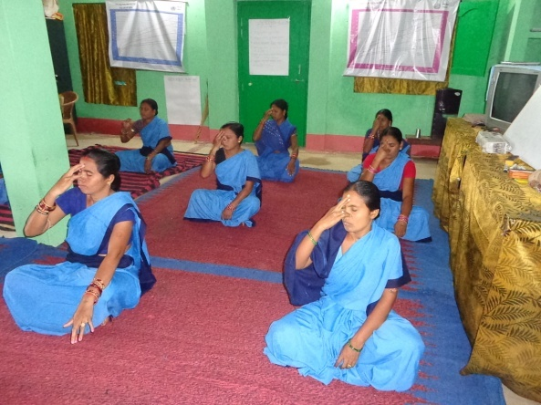
Yoga is enjoyable which build a good physique, sound health and fitness that in turns build self confidence and positive thinking. The purpose of yoga education can help in the task of providing holistic education and keeping the body, mind & soul in proper condition. The organization since its beginning provides physical & yoga services for all category people. During the year under report on celebration of International Yoga Day the organization RYS organized a short time training course for the ASHA in the premises of the organization at railway station road, Balangir. Further to aware the community about the Yoga & Naturopathy, its cost effectiveness, affordability and benefits for prevention and treatment of common ailments the organization also organized some awareness activities on the issues.

COMMUNITY PROCESS ACTIVITIES UNDER NUHM
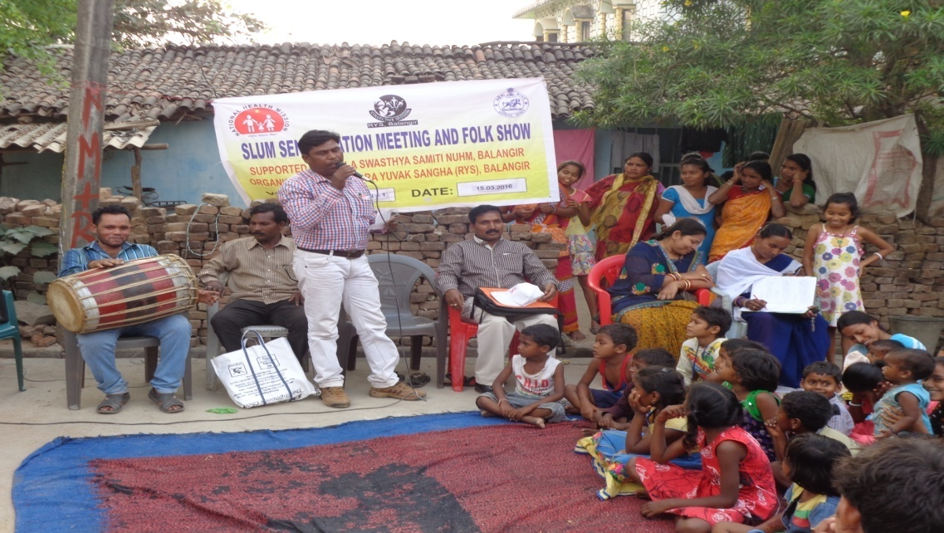

Slum Level sensitization Meeting & Folk Shows & Orientation Of Ward Kalyan Samiti
Previously the services of ASHA was only limited to the rural belt through NUHM. Looking to the successful achievements of implementation of NUHM & engagement of ASHA the Govt. has extended its activities to the urban areas also. However under the guidance & support of the NUHM, Balangir the organization. during the year under report carried out the following activities.
- 24 numbers of Slum Level sensitization Meeting and Folk Shows were organized being selected Slum areas of the Balangir Municipality by the members of the organization RYS with the support and guidance of NUHM staff.

- 21 numbers of wards under Balangir Municipality 21 numbers of Ward Kalyan Samity were constituted by involving the counsellors and ANM for achieving better health status of the people under the municipality along with 6. Numbers Orientation Prog. Of Ward Kalyan Samiti were organized being selected ward areas of the Balangir Municipality by the organization RYS with the support and guidance of NUHM staff. And the urban slum areas of Balangir municipality of Balangir District during the year under report.

EDUCATION
Education is a most effective factor which can break the vicious crick of poverty, exploitation, proneness to ill health and mortality and the process of marginalization. Govt. has already spent huge resources in this sector but failed to make any visible impact in the educational scenario of the most under privileged. Hence realizing the important role of education his effective Social change as well as the drawbacks in the present education system, RYS has intervened in the field of education and carried out the following activities in the operational areas for the Socio-economic development of the Society.
- Awareness on RTE Act:
The organization RYS organized awareness activities in 7 villages of Saintala & Gudvela Block during A pril & May 15 on Right to Education Act so as to promotion of Child Education in the area. In the camps the parents, educated mass of the area, NGO people and SMC members along with te achers of the area were made aware on the following matters.
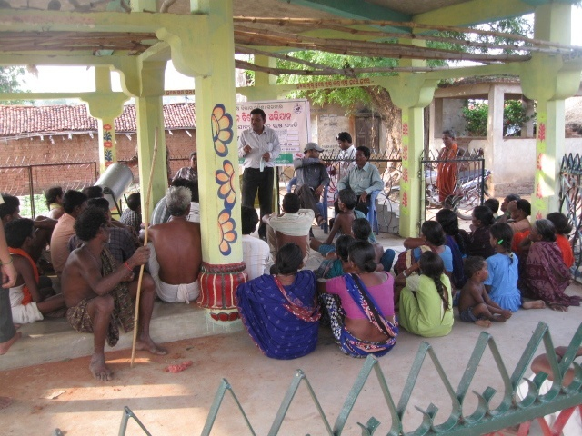
- What is Right to Education Act
- Scope & activities under RTE for universalization of elementary education
- Regarding the alarming figure of dropout & non starter of the area.
- Causes and probable solution to overcome the situation.
- Enhance of enrolment figure of girl children.
- Checking of dropout rates and keeping the retention cent percent.
- Procedure to ensure community participation & ownership.
It was further decided to strengthen the SMC to look after all the above matters properly and take necessary steps to overcome the problems for better education.

- Library & Information:
In order to provide reading facilities to the interested group the organisation RYS established a centre library in the office premises of the organization at railway station road, Balangir for the last 12 years. The central library has various Books to fulfil the need of different categories of readers including the neo literate. A number of people from Youth Club, Yubak Sangha, Youth Mass, students & Old Aged get the opportunity of reading service of useful books. The institutional Library is having reference Books, Text Books. Literature, Mythological, and Historical Books, Magazine, Booklets, Newspaper, Journal etc. Especially youth and students of the area availed the opportunity of the library during the reporting session.
- Literacy Awareness
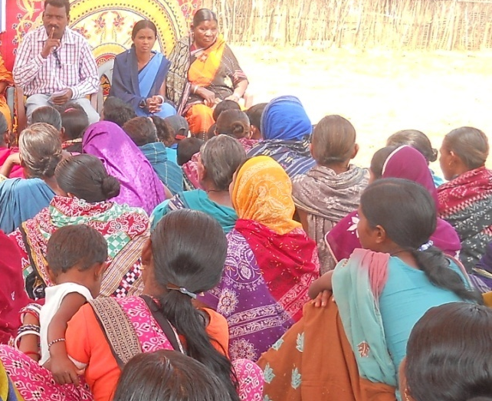
Literacy is the most vital pillar of a democracy which laminates in all round development of the country. But in this part literacy is very low and alarming especially among female which is the source of their suffering on all points. So to promote and enhance the rate of literacy 2 numbers of workshops were organized at Guna & jamut of Gudvela Block & Sujia of Loisingha Block with active participation of the local Preraka & Asst. Preraka of A.E.C., NGO & CBO activists and experts, educated youth, teachers and some potential stakeholders of the area. These activities were organized during Sept. & Oct. 15.
- School Development Plan:
To make the programme and activities of the primary schools of Gudvela Block more effective & harmonious the organization RYS by the support the school authority carried some awareness cum action activities relating to school development plan. In the activity details plan in advance of the schools of 2 educational clusters of Gudvela Block & 3 educational clusters of Balangir Block area were being prepared by the active participation of the school authority, CRCC, SMC members. However to provided inputs experts from the organization attended the camps. This activity provided ample scope for the school authority to execute different activities in the school in a targeted and effective way.

WOMEN EMPOWERMENT:
Development of women is the major thrust area of every country. Without the development of women, the development of the society and the country as a whole is beyond imagination. So empowerment of the women socially, economically and educationally is one of the greatest areas of concern of the Government today. Inspite of several programmes the quantitative and qualitative improvement is not yet possible. The progress of poor women of remote concern is not so pleasant and encouraging rather the women groups are still suffering a lot and struggling for their survival even after 69 years of independence. They are being exploited, tortured and harassed in the area by the orthodox society and also by family members. So with a view to provide them support services for their improvement and empowerment the following activities were taken up by the organization RYS during the reporting period.
1.Programme on Legal Awareness:
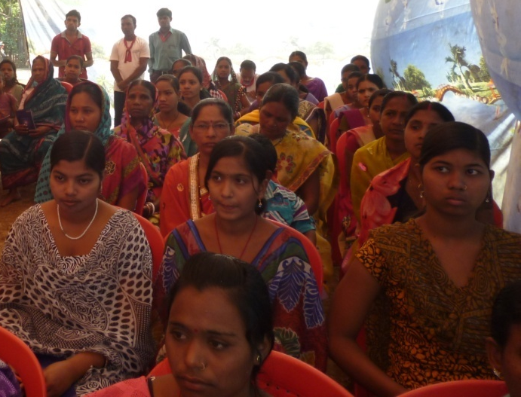
Any kind of violence against women is a crime which ought to be deplored. Since its inception the organization is working to raise voice against atrocity against women. During the reporting period undertook a programme to make the women aware regarding various panel provisions against women atrocity. Awareness activities were organized during Nov. 15 & Dec. 15 in 6 villages under patnagarh & balangir Block in Balangir district. The organization RYS invited members of judiciary and social activists to explain to the people regarding various legal provisions and protection available to the women. The invited RPs discussed on the following points
- The existing provisions on women atrocities
- The Domestic Violence Prevention Act
- Sensitized on law against women atrocities
- Property right & Hindu Marriage act
- Generate demand for various services provided by public health system
In order to stop the heinous activity of Trafficking Women for Commercial Sex the organization tried to raise awareness among the people. Several IEC campaigns were launched in the villages to protect the women and keep track of suspected elements operating in the villages.

2.SHG promotion :
The organization RYS aims at empowering women through formation and promotion of women’s self help groups. During the year under report the females of different villages in the district of Balangir were being encouraged by RYS to form SHG by which they would be able to unite together and think about their betterment for present and future living. Further they were made understand for their economic empowerment and social development through training of SHG. More than 150 nos. of SHG have been formed till today by the organization RYS. All the self help groups are having their monthly membership saving in back account. Through small business they are earning little extra for their families. As a part of the programme & for the smooth management of SHG the members of the different SHG were provided training in the training camp organised by RYS in 3 numbers of batches comprising of 35 numbers of members in each batch. The programmes were taken place during Dec. 15 & Jan. 16.
3.Leader’s training:
The organization in order to capacitate the leaders to manage & mobilize the group in a proper way organized leaders tarining camp the premises of the organization RYS. In the training camp the following content were covered & to train the group experts of the concerned field were invited to the camps as resource persons.
4.Content of the training :
- Mobilization of group & Group management
- Role of members & Role of leaders
- Resource tapping & mobilization of funds
- Type of records to be kept & Procedure to maintain different records
- Preparation of Cash Book & Bills and voucher
- Maintenance of loan records
The trainings were organized for 2 days during Feb. 16 However 106 members of different SHG were trained on the topics.
5.Activities Of Mahila Arogya Samiti & Ward Kalyan Samity
Previously the services of ASHA was only limited to the rural belt through NUHM. Looking to the successful achievements of implementation of NUHM & engagement of ASHA the Govt. has extended its activities to the urban areas also. However under the guidance & support of the NUHM, Balangir the organization RYS during the under report carried out the following activities in the area under Balangir Municipality
- 50 numbers of Mahila Arogya Samiti have been formed and the members of the Samitiy were strengthened about their role and responsibilities.

- 17 numbers of ASHA were being selected by the untiring efforts of the staff and members of the organization RYS in the slum areas of the Balangir Municipality by the support and guidance of NUHM staff

- 21 numbers of wards under Balangir Municipality 21 numbers of Ward Kalyan Samity were constituted by involving the counsellors and ANM for achieving better health status of the people under the municipality with support and guidance of NUHM .
Skill Development Training
For the sustainable livelihood of the rural youth,cbo/ngo members the organization RYS used to organize training programme for skill development of the group on different suitable vacation like previous year the organization from its own endeavour & by the active cooperation of the beneficiaries arranged skill development training along with business management in its area of operation under Balangir District. However skill development trainings on the following vocations were taken up during the year under report.

I.Mushroom Cultivation
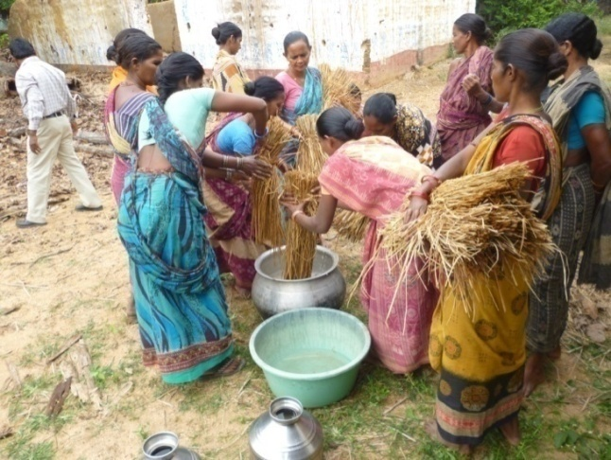
Mushroom cultivation now a day is one of the better farming that provide ample opportunity for the farmers, individual or group a better learning source. Because marketing of mushroom is very much encouraging in the district of Balangir as well as other part of the state and the some has been sold like hot cake in the market. Hence the organization RYS arranged as good as 2 numbers of training at Chinched under Gudvela Block & Budhipadar under Loisingha Block during April & may 15 for the SHG leaders of the operational villages of the organization. In the trainings near about 43 SHG leaders & members of the area were trained on the technique of cultivation of mushroom of different types. To train the group expert were engaged. Besides the above the trainees were also provided knowledge on quality control, packaging, costumer dealing and marketing of mushroom. This business provided ample scope for the SHG to enhance their economy sector.
II.Training on Phenyl Making:
The organization RYS like previous year under took activities to enhance the skill and competencies of the youth on different suitable vocations. In this connection during the reporting period the organization arranged training on phenyl making in the office premises near railway station, balangir during Nov. 15 for 3 days for the youth girl. In the training 22 numbers of youth girls were benefited. To train the group on the trades MCM on the said vocations were engaged. However to market their products the organizations people were also taking initiatives.

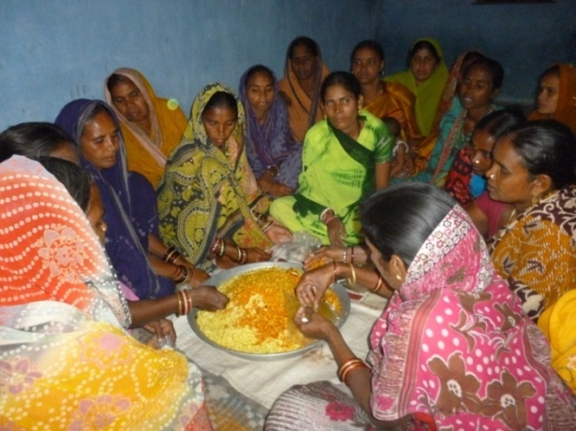
III.Training on Making of Mixture
The organization arranged training programme on Mixture preparation during Dec 15 at Rameswarnagar of Balangir Town for the SHG leaders of the area. In the training near about 33 SHG leaders & members of the area were trained on the technique of preparation of mixture. To train the group besides the expert of the organization, RYS invited experts from outside. This business provided ample scope for the SHG to enhance their economy sector.
IV.Market Support Services:
Without having any knowledge on the marketing the SHG members were exploited like anything for selling their products. At time they used to sell their products on low prices. So to market their products the Association RYS has a good contact with some institution, ships and traders. Further the organization has also some consultant and Agent to identity the possible market of the products produced by different SHG associated with the Association. Further the trainees of all the trainings were also provided training on quality control, packaging, costumer dealing and marketing of produced materials.
Training of ASHA:
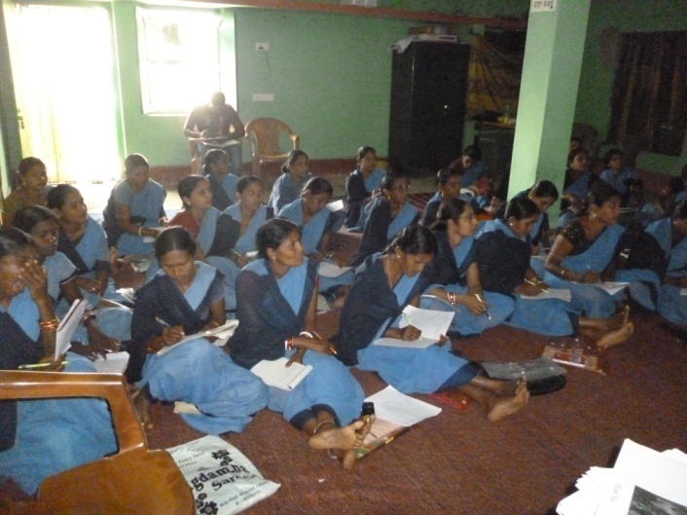
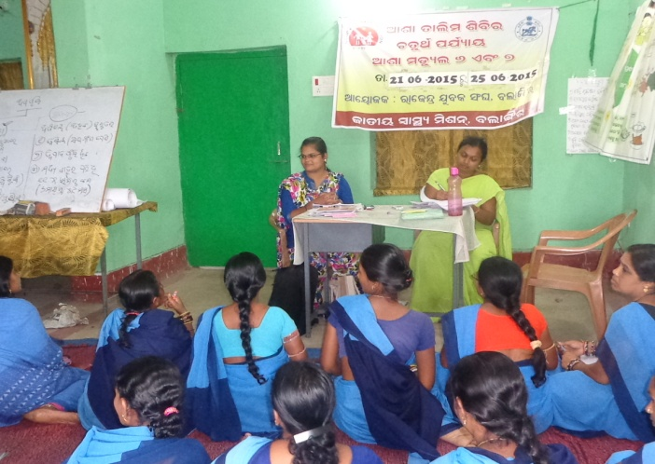Inclusion of ASHA in health sectors is a blessing to the eligible mother & the infant. ASHA is one of the important workers in NRHM at grassroot level to ameliorate the health status of the people. In order to capaitate the ASHA in different health related issues and challenges and make her capable to handle different works and activities assigned her in a proper manner the Govt. has provided training to the ASHAs in a continuous phase. To make the programme successful the Govt. has organized training on PPP mode and entrusted some leading NGOs for better organization of the training programme. In this connection RYS also selected & entrusted the to organiza training programme of ASHA in two districts i.e. Bargarh & Balangir. However during the year under report by the extensive support and guidance of the District health administration Balangir the organization RYS conducted training of ASHA of Agalpur, Balangir & Loisingha on 6th and 7th modules.
skill DEVELOPMENT AND vocational training 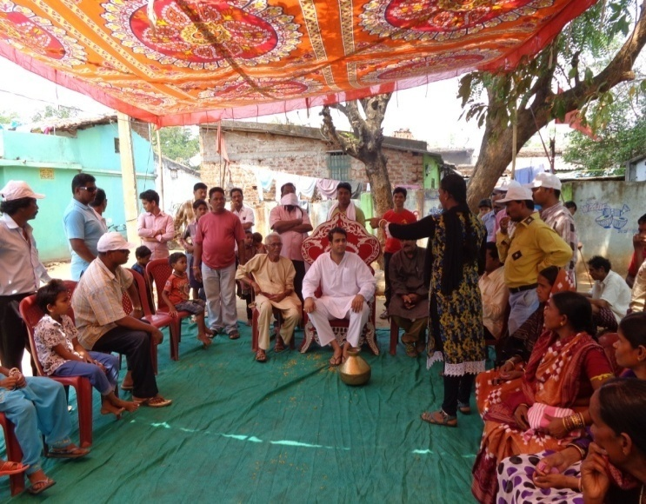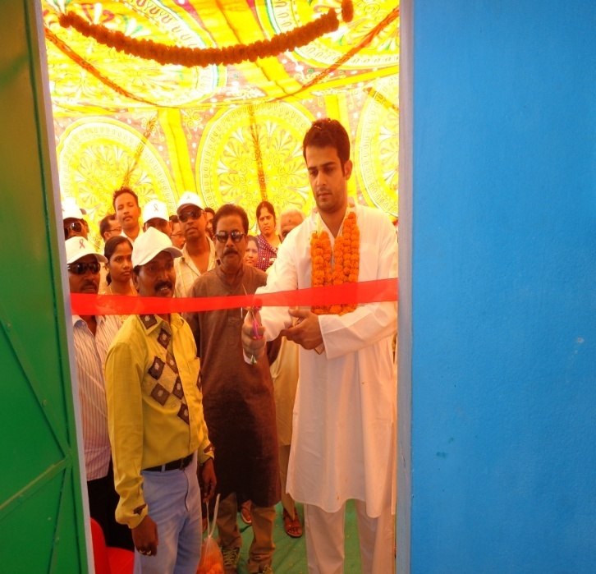
. In order to provide training to the identified interested group on tailoring & computer during the year under report the organization RYS in collaboration with of Vedant Foundation, Mumbai carried out the following skill development training camps in its area of operation
I.Computer Training :
A number of youths having requisite academic qualification are found unemployed & they are in an instable condition. The organization RYS was having target in extending helping hands for strengthening such youth and increase their knowledge and upgrading the skills in different trades through training programmes. Computer is absolutely necessary asset as it minimizes and solves any type of critical work. The demand of the technology has been increasing day to day in the public as well as in the private sectors. Hence to make the educated unemployed youth capable to cope with the job market provided computer education. Looking to the market need and realizing the unaffordable capacity for computer education of the students/ parents RYS started a training centre on computer education for the interested students in a very nominal price by admitting 50 numbers of students of the locality. To impart the technique on DCA one expert instructor in the field is engaged. The centre was started in the premises of the organization RYS.
II.Tailoring Training
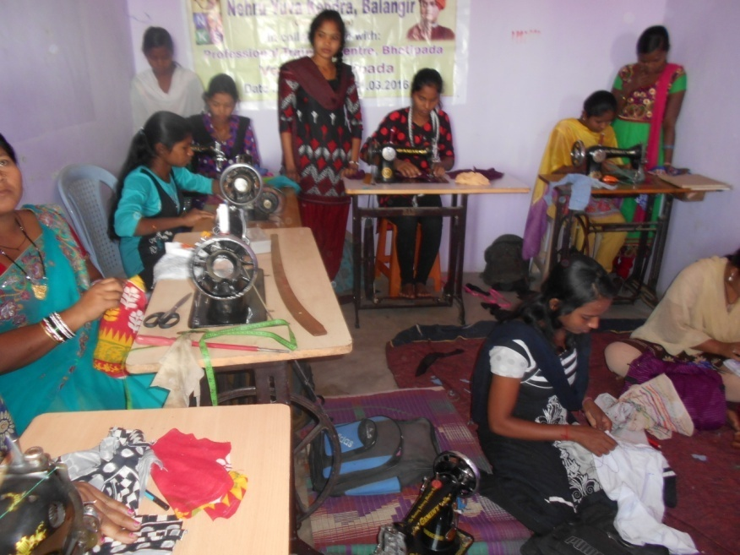
Now a days the Tailoring work has got an important place in tailoring & has wider demand in the market. As the Tent Owner, shops, institutions and individual are having an attraction to wards dress materials & decorative materials. Hence looking to the market potentiality of such materials with embroidery work during the reporting session some Youth girls who have already interest on tailoring were admitted in the training centre on the modern and improved tools and machineries used in tailoring & embroidery along with stitching technique of the same. 40 numbers of girls were trained during the year under report. The centre was started in the premises of the organization RYS.
Sensitization Prog. on Swachha Bharat Avijan:
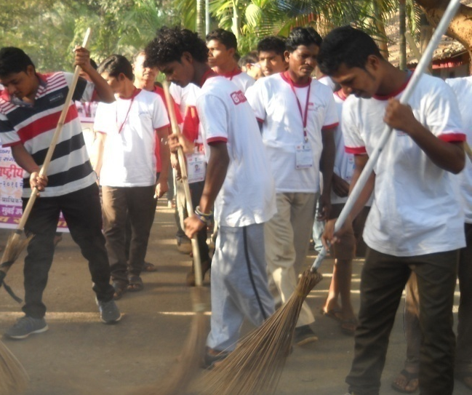
To get rid of from diseases one has to keep the sanitation and personal hygiene in proper condition and sanitation is the simply important factor for a healthy environment and wealthy people. In this connection to keep proper sanitation and availability of safe water the Govt has established Water & Sanitation Mission throughout the country. But the same has yet to take a desired shape. However this endeavour of the Govt. has brought about some development in the sector but still more to be done for better achievement. The latest innovative launched by the Honourable Prime Ministe r of India to this effect is Swachha Bharat Avijan. During the year under report the organization RYS carried out different activities under the scheme in different parts of Balangir District. However under this programme activities were being carried out during the year under report such as Strengthened Village Water Sanitation Committee (VWSC) in different villages of Gudvela & Saintala Block, make liaison with the parent departments for proper execution of work, ensure community participation & ownership at all stages, how to keep the household and village surroundings clean, development of community compost pit & Management of waste. Most of the programmes were conducted during June, July & Aug. 15. During the process some community compost pits were constructed in some villages by the help of the community. However the BPL families were tagged with the R.W.S.S. for installation of IHHL.
FOREST & ENVIRONMENT
Forest is the very valuable renewable natural resources providing the vital life support system on this planet earth. It performs multiple functions including that of carbon uptake and sequestration and provides various other economic benefits and environmental amenities of public goods type. Being the repository of biodiversity, it constitutes an essential element of sustainable development. With the 1st growing human and animal populations, industrialization and urbanization, the demand on forest resources has been progressively increasing consequently. This valuable resource is being degraded and depleted all over the world and threats the human mass on their survival. To overcome such problems and to increase the environmental status the Govt. of India has been putting in Herculean efforts but the same has not yet to be achieved up to the work and the a learning situation due to lack of awareness commitment and coordinated efforts at all level. So for the augmentation of the environment situation keep the ecological balance in a proper condition and to participate in this global issue. The organization RYS during the reporting period was coming with some following efforts.
A.Plantation & Care:
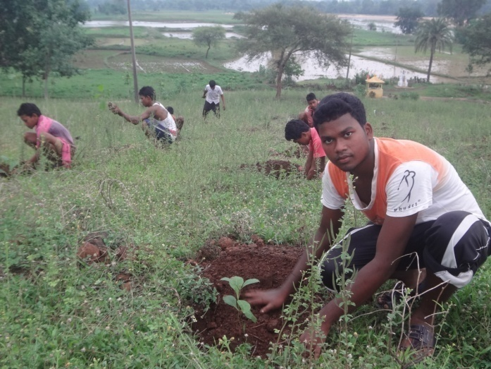
Most of our populations particularly the illiterates and those who are living in tribal areas are not aware about the consequences of slashing the trees near human habitation. Even most of our civil society members like, PRI Members, Youth Club Members, women SHGs do not understand the gravity of t he fact. .So with a view to aware the rural mass on the importance of plantation the organisation RYS like previous year celebrated the Banamahotsava at Nirbachan on 6th of July 15 and had taken plantation activities in the school campus at the wasteland of the area and on the roadside of the village by taking the active support of the volunteers, youth, students and SHG members of the village along with the staff and numbers of the organization. The community and local CBOs were encouraged to take care of the plants. However the organizations people also visited the area from time to time to see the growth of the plants and to provide proper guidance to the people regarding healthy growth of the plants. Further during celebration of Banamahotsava a meeting was conducted in the village were the participants were educated regarding the need and importance of plants for the survival of human mass and other living creature.
B.Nursery & Seeding.
One of the important activities of the organization is to develop nursery. However during the reporting session the organization RYS has developed a community nursery at Khujenpali of Balangir Block and the area where the nursery has been raised by the organization for the last 5 years. The nursery is having valuable type of fruit bearing, vegetable and medicinal plants. As much as 40,000 plants were being procured and nurtured during the last year and the same were being sold to the institutions and individuals at large scale. Besides the above some awareness camps were also organized for the SHG members and farmers to promote nursery in their backyards.

AWARENESS PROGRAMME:
The people of many a parts especially of remote concern are completely unaware about different activities relating to health, sanitation, education, legal based activities etc. and for the same the poor innocent mass are suffering a lot in all most all the sectors and they are being exploited many times by the touts and notorious persons along with nasty politicians. Hence to educate the mass on some important fundamental issues and challenges the organization RYS carried out the following awareness activities in its operational area.

a. Awareness on MGNREGA:-
To eradicate poverty the scheme MGNREGA is an excellent programming for the poor mass to overcome poverty. But it is a matter of regret that without having proper knowledge on this scheme the poor mass suffer a lot. Hence to educate the people of different villages of Gudvela & Deogaon Block, RYS carried out different awareness activities, like workshop, meeting etc. on those villages to educate the mass on different aspects of NAEGA such as Right of the people to know the information and resources on the Govt. and NREGA programmes, procedure of applying for registration in Panchayat, availing of job card,availing in 100 days work, about their right to access to govt. support and basic facilities to ensure a sustainable future for the rural mass.

b. AWARENESS ON PMVKY:
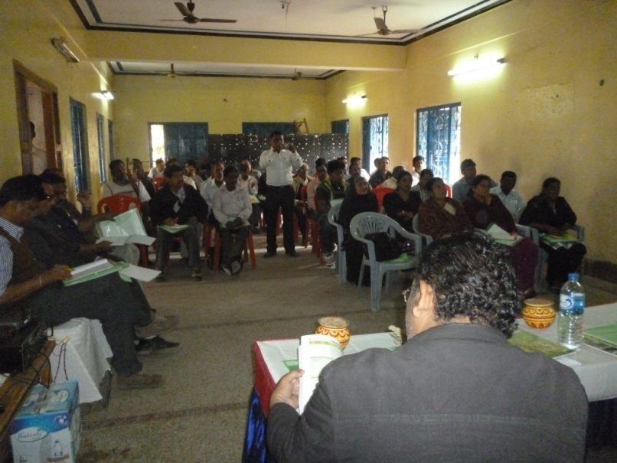
Pradhan Mantir Kaushal Vikash Yojana (PMKVY) is skill training scheme of the new Ministry of skill development & entrepreneurship (MSDE).The objective of this skill certification and reward scheme is to enable and mobilize a large number of Indian youth to take up outcome based sk ill training and become employable and earn their livelihood. For the sustainable livelihood of the youth the organization RYS used to organize training programme on skill development for the youth group on different suitable vacation Hence to aware the Youth regarding the benefit under the scheme PMKVY, monetary reward would be provided to trainees who are successfully trained, assessed and certified in skill courses run by affiliated training providers the organization conducted 6 numbers of awareness activities in Balangir Block during the reporting period.
c. Awareness on Environment
The climate has been changed to an alarming condition for which the entire ecosystem is at stake. Hence for the augmentation of the situation to keep the environment in better condition for the survival of the living creature the organisation RYS has executed and implemented a number of programmes. However during the reporting session the organization organized 3 numbers of awareness camps during the reporting session for the promotion of the situation at different locations of Loisingha, Saintala & Tusra under Balangir district under the theme climate change. In the programme NGO activist, Officials of line department, Environmentalists, SHG leaders & Teachers were invited to the seminar and the following discussions were taken up in the seminar.
- Augmentation of sanitation and personal hygiene
- Promotion of house hold and village dustbin
- Popularization & Construction technique of compost pit
- Preparation technique of vermin compost and bio compost
- Encourage for Cleanliness Drive and cleaning of water bodies
- Educate the people for use and handle of water
- Popularization of Bio fertilizer in place of Chemical.

To impart training on the topic experts from outside as well as local resource persons were invited to the camps

Awareness on RTI
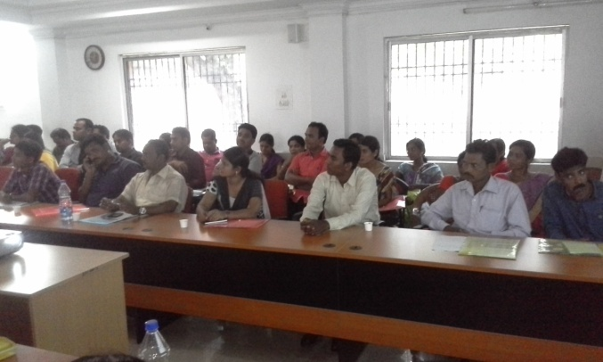
The people of rural habitation of the area are quite unaware of the act relating to Right to Information. In order to educate them on different aspect of RTI Act., the organization RYS organized 3 numbers of workshop at Gudvela under Balangir District during Jan 16. Some eminent journalist, Social activities was invited to address the issue of RTI and encouraged the participants to fight for their Right to Information. The participants could be educated that every citizen has right to information on payment of requisite fees, they can demand and receive details of Govt. progra mme being complemented towards rural development on any other schemes and the particulars of work done as well as details of expenditure incurred thereon. This empowered local communities to have access to resources available for their development. It checks the level of corruption to rural development programme. However in the workshop the participants were educated on the aims and objectives along with scope & activities of RTI, different officers such as PIO, 1st appellate officer, 2nd appellate officers and their responsibilities, different formats & procedure for asking information & procedure to get information
Consumer Awareness Programme

The people of many parts especially of remote concern are completely unaware about different activities like a rally on the eve of consumer protection involving. Students, and villagers was organised at Budhabahal where 130 participants joined. A public meeting was also held in village Khajurpada under Bughabahal G.P. of Saintala Block & Sargaj G.P. of Tarva Block participants made aware on consumer protection aspects.
R.Y.S Balangir has organised a seminar of consumer protection and right at Gandhi Bhawan on dt. 15.03.05 65 nos of people from different village area of Balangir district. The related expert, advocate B. Sahoo delivered a speech for implementation of Acts & Rules relating to consumer act 1986 to mobilize young stars by instilling in them the spirit of protection of consumer right and to strengthen the consumer movement of the district. All the participants attained are advice of make awareness in their locality.
HUMAN RIGHT
The human right cover vast field and the country also witness large scale human right valuation R.Y.S. organised awareness camp on human right & highlighted to the programmes some human right activities who to described pros & cons and called upon to participants for making the people aware of their locality to have their right.
A human right team was constituted headed by advocate S. Kumar to save guard the layman for enjoy the provision of human right.
During the year two no. of awareness programme were conducted on human rights & a meeting was also organised presided by advocate B. Sahu. Where 240 participants attended of Saintala & Tarva Block area. Likewise another awareness programme was also conducted at village Tikrapara & Sargaj with meeting. This programme was also participated by 120 youths & PRI members and other villagers.

Seminar on Human Rights:
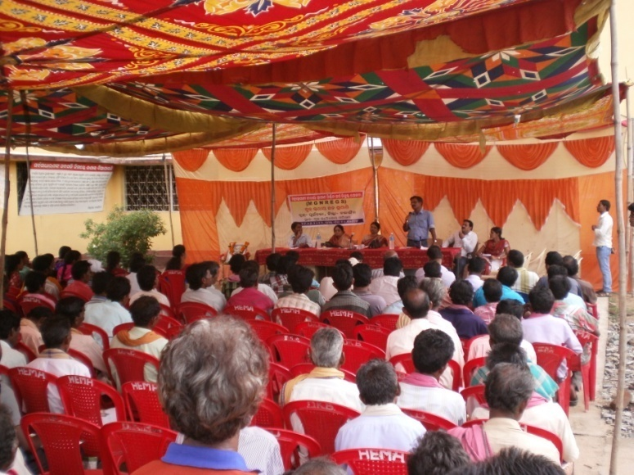
It is almost found that inspite of strong law to keep up the human rights the same has always been violated, especially the rights of the weaker section of the society have been violated to a greater extent and the happening is only due to lack of education, knowledge, orientation, information and awareness of such people. It is because of the unconsciousness at people’s level and some time negligence at Govt. level. Due to such practice the people especially of remote concern are suffering a lot in protecting their rights. Hence realizing the fact the organization RYS arranged a seminar by inviting the youth volunteers, SHG members, ngo activists & some leaders of the area during celebration of the Human Rights Day on 10th Dec. 15 at Malmunda under Puintala Block. In the seminar discussion were made relating to Human Rights and fundamental rights & the participants were educated regarding the rights and acts relating to human mass and the procedure to avail and exercise the rights. To educate the group advocates of Balangir were invited to the camps.

Demand Generation on Financial Literacy & Inclusion:
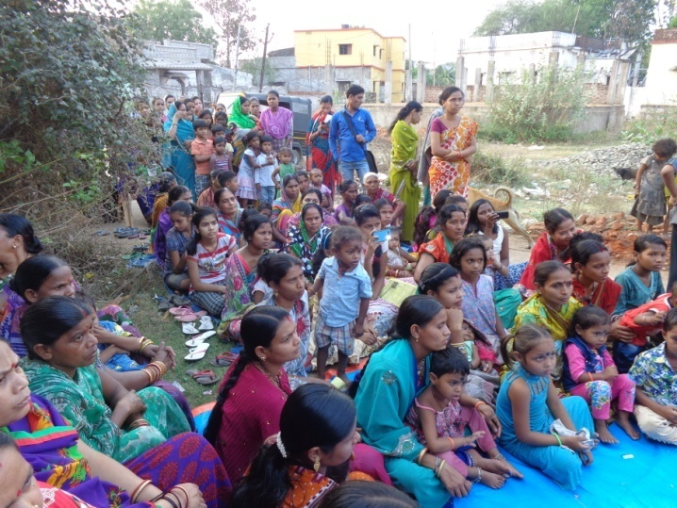
Financial inclusion, when promoted in the wider context of economic inclusion, can uplift financial conditions and improve the standards of lives of the poor and the disadvantaged. It could enable a higher disposable income in the hands of rural households leading to greater savings and a wider deposit base for banks and other financial institutions Thus, financial inclusion could be an instrument to provide monetary fuel for economic growth and is critical for achieving inclusive growth. Hence to participate in the process the organization RYS carried out 5 numbers of awareness meetings in different selected locations of Loisingha, Gudvela, Balangir, Puintala Block of Balangir District & Tarabha Block of Subarnapur District during the year under report in order to educate the people regarding the importance of financial literacy & financial inclusion and the procedure to involve in the schemes along with the scope & benefits such as insurance benefit, pension scheme, sukanya Samrudhi yojana etc under the schemes provided by the Govt. further the participants were also educated about the opening of pass book, availing & use of rupe card, benefit of over draft etc.
RALLY ON ROAD SAFETY
Due to increase in population, urbanization, the so called fast & advanced world, modernization and luxury life of people the numbers of vehicles on the road is increased more than the expectation. To control and avoid accidents the Govt. has promulgated the traffic rules which is violated many times and thus accidents occur large in number by taking a numbers of lives and injured innumerable. It is observed that due to Lack of good road sense unaware of traffic rules. Jumping signals and not knowing what lane driving means, always results in accidents. Further other major causes for road accidents are speeding beyond the limits inside the town area; Drunken driving, overtaking dangerously etc. so to aware people on the above mentioned problems to avoid accidents. With a view to aware people on road safety majors and traffic rule the organization RYS organized awareness Rally in 2 locations of Balangir & Puintala Blocks under Balangir District including the some private Colleges under Balangir District during observation of 25th road safety week. And participants of the meetings were educated and aware on traffic discipline to prevent accidents,
public cooperation in preventing accidents donning helmets, No amount of laws can enforce traffic rules without the cooperation of the public.

AGRICULTURAL ACTIVITIES:
In rural India most of the families depend on agricultural activities for their sustainable livelihood. But due to paucity of water, uneven rain, massive use of chemical fertilizer, use of pesticide and recurring draught the yielding of crops have been decreased substantially which in turns put an adverse effect on the economic sector of the poor people. Hence at this present juncture steps should be taken to overcome the problems. However during the reporting session the organization RYS initiated steps to take some following activities in its operational area.
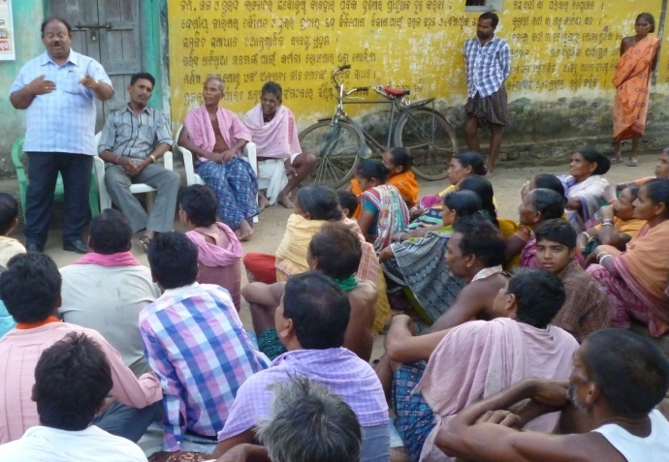
- Training for the farmers was organized at Chinched of Gudvela block du ring August 15 regarding the latest technique on SRI method of cultivation & Maize cultivation. The participants were provided with different type of technologies for cultivation of paddy & Maize. Experts from local agricultural department and experience persons having knowledge on farming were invited to provide training to the participants.
- During the reporting session the organization RYS promote Krushaka Club in the area and in this connection it has formed 2 number of Krushaka Club. The members of the Club were educated on the beneficial aspects of the krushaka club in the orientation camp at Sibtala of Balangir Block during June 15regarding new and modern technique of cultivation, the cropping system, Agricultural loan, repayment of loan on easy instalment availing of Kishan Card etc.
- In order to capacitate the group to make them capable to address the issue related to agricultural farming the organization has conducted 3 numbers of sensitization camps in different location under Loisingha & Saintala Block during May 15 where the participants were aware & educated about the scope & activities of ATMA, different improved variety of seeds, subsidy, participation of farmers for BGREI, Khadya Surakshya Mission & its activities & support, farming other than paddy & its benefit etc.
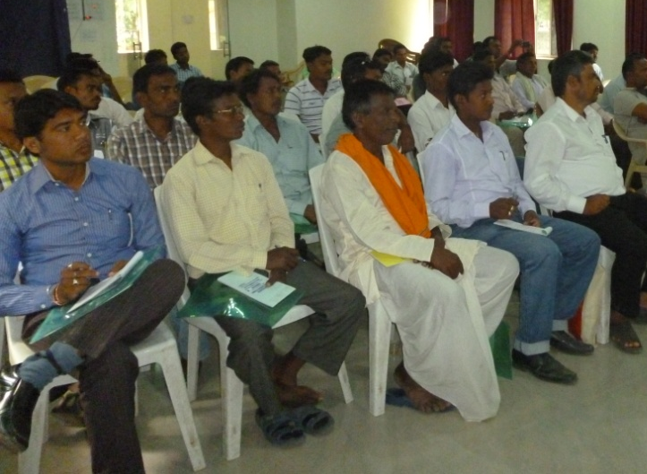
- Livelihood Training
It is found that a number of people in the area of operation of the organization RYS are coming under BPL and they are treated as Most Marginal People. Hence realizing the fact the organization by taking the Most Marginal People of the area train and orient them on the beneficial schemes of Govt. However for their sustainable livelihood JLG were promoted among the people and the members were trained on different skill to enhance their economical status. Further the JLGs were also tagged with some financial assistant. Besides the above during the follow up activities the staff and members of the organization ensured whether such most marginal people avail their rights or not & whether they were provided with IAY, PPS, Social security, wages etc. or not such activities has an immense help to develop the economic front of the client group. Again some of the poorest of the poor were provided with financial support to start their traditional business in an improved way.
YOUTH DEVELOPMENT
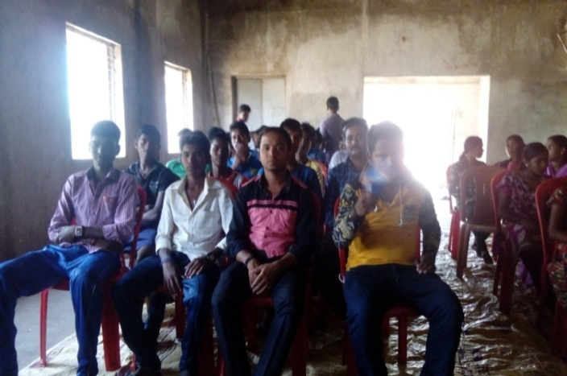
Youth is the main power in every society and they can build a strong nation. Youth are treated as the present assets of the country and their services are used for the development of the country in all sectors. But it is matter of regret that due to factors like improper orientation, lack of training, counselling and motivations and above all employment problems the groups are in disorganized and in stable condition. However to provide them some knowledge and to enhance their skill and competitions in different sectors and mainstreaming them in the social flow the organization RYS in order to empower the youth of the area of operation of the organization & invited more than 50 numbers of potential youth volunteers from different youth of Youth Club & yubak Sangha of Balangir, Puintgala & Loisingha block to the training camp at the office premises of the organization at Balangir during celebration of Youth Day on 12th Jan. 16. The participants joined the programme and they were provided knowledge on leadership and life skill development and all other related matters. The R.P from diffident sector such as NYK, ICDS, Bank and NGO were invited to the training camp and they suggested networking with related to the line Department for promoting policy intervention measures and advocating with govt. for promotion of social economical development of the members. Besides the leadership training debate & essay competition was organized by inviting the youth of the different youth clubs of the area to increase their knowledge & confidence and for keeping the unity & Integrity. Further the organization mobilized the youth to motivate & educate people on some fundamental issues and challenges.

SOCIAL ACTIVITIES:
The organization RYS has been extending helping hands & organized different social activities in its operational area for the betterment of the people. During the reporting session the organization carried out the following social work in its operational area.
- A flood relief camp was organized near fasad under Loisingha Block to provide foods to the flood effected people.
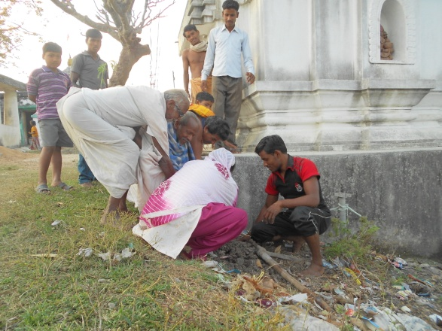
- During the hot summer to provide drinking water facilities to the people on street the organization install a Jalchhatra at 3 numbers of places under Balangir Municipality for 3 months during April 15 to June 15.
- Some Roads of Chikalbahal of Bolangir Block which are in very poor conditions were made repair and cleaned by the active co-operation the members, youth and volunteers. However the general people were motivate and made aware to keep the road clean of their concerned area
- Some patients who are in need of treatment and want of financial supports were provided with some financial assistant by the organization RYS. However 3 nos. of patients who are in serious condition were partly supported for treatment at Burla. Besides the above the organization helps a numbers of patients in getting proper treatment in the head quarters Hospital at Balangir
Cultural Activities
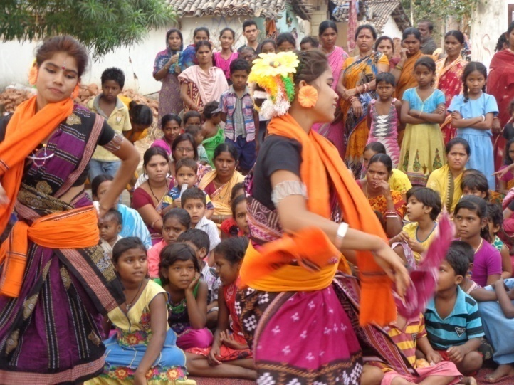
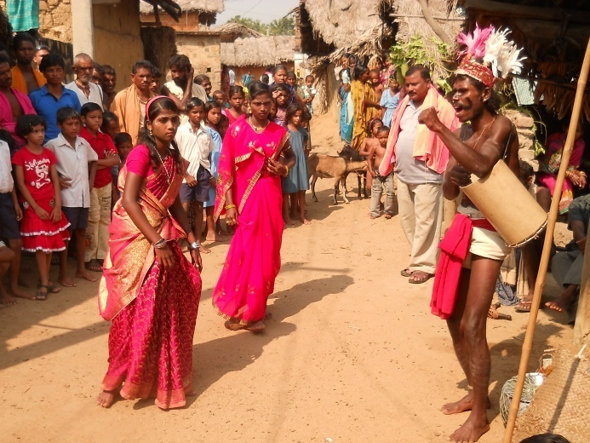
- There has been an unprecedented rise in the electronics media which has affected adversely the traditional music and dance forms. The organization is trying to preserve the traditional folk & tribal dance, music and art forms like Ghuduka, Dalkhai, Danda Nata etc. by organizing them regularly. Apart from entertainment these popular art forms are often utilized in a creative way to disseminate message on social evils. An effort is also made by patronizing performance of dying and languishing song and dance forms. Street plays were organized by the artists from time to time in its operati onal area to educate the people on different welfare activities of the Govt. the organization RYS organized during the reporting session a folk dance competition was organized in the office premises of the organization at Balangir with a view to promote the folk dance and folk artists in the area. In the competition more then 4 numbers of troops & 12 numbers of solo artists attended form different nook and corners of the District & the competitions was very much interesting and attractive. The viewers from throughout the district availed the opportunity to enjoy the competitions and praise the artists for their performances. The winners of the competition were awarded with gift & prizes along with the certificates where as all the participants were provided with certificate of participation. The organization made efforts and encouraged the folk artists to attend different block & district level cultural functions like Loka Mahotsava.
- OBSERVATION OF R. N. SINGH DEO JAYANTI
- The great ruler of Patna State & the front line leader of Odisha the Ex- Chief Minister of the state of Odisha was one of the great personalities responsible for the merge of the princely state in Union of India. His character & integrity constituted the foundation of his greatness. He is a committed & dedicated person & during his reign as King as well as Chief Minister he had dedicated much of his life for the welfare of the
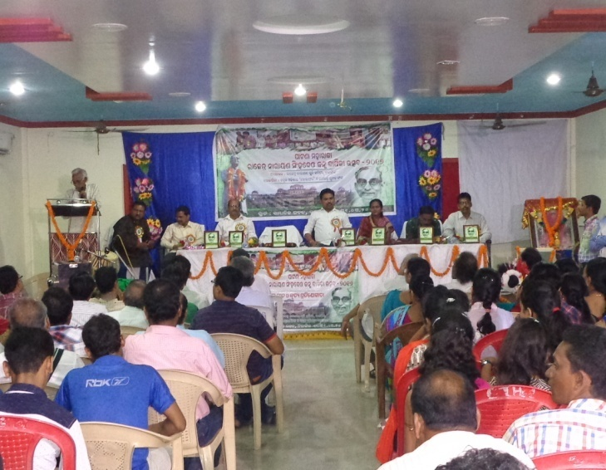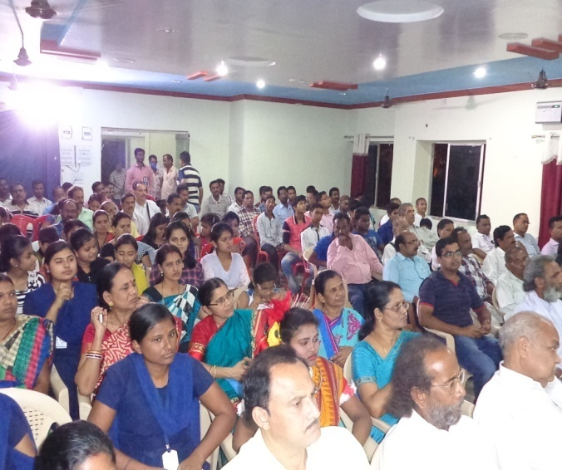
people. Impressed by the ideologies of the great soul R. N. Singh deo the organization Rajendra Yubak sangha came into being in the year-1991 and since then it has been observing the Jayanti of R. N. Singh Deo in order to remember his good work and spread his ideologies among the people of all walks of life. This year also the organization RYS observed the Jayanti on dt. 31.03.2016 in the premises of the organization and on the day chief guest invited to the meeting was none other than the grandson of Sj. R. N. Singh Deo Mr. Arkesh Narayan Singh Deo.
RURAL SPORTS:
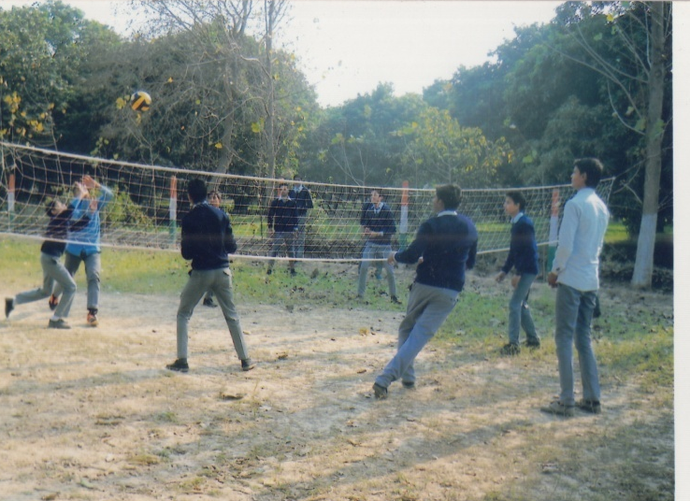
To keep the body, mind and soul in proper condition and to build a good physique playing of different sports and games is the right medium. Besides the above organisation of different tournament, sports and games to increase the unity, integrity, fraternity and brotherhood among the players and for local talent search the organisation RYS like previous year organized different sports activities during the reporting period. A short description of the sports activities that were taken during the session are as follows:
- The organisation organized a Block level Volleyball tournament during the reporting session at Puintala on Nov.15 where 12 numbers of Volleyball teams from different part of the Block attended.
- The organisation organized a District level Football tournament during the reporting session at Railwaystation area on Sept. 15 where 18 numbers of Football teams from different part of the district attended.
During the reporting session a number of eminent personalities were attended as guest in the tournament to encourage the participants and members of the organisation. Prizes and Gifts along with certificate of appreciations were awarded to the winner, runner and to the cricketer for their outstanding performances.

FUND RAISING ACTIVITIES :
Keeping in view of sustainable developments of the welfare activities of RYS the organization has stressed upon for developments of its own resources besides subscription, membership fees, Donation & Community Contribution and except Govt. grant. However the following are the fund raising activities of RYS during the year under report.
- By organizing vocational Training
- By organizing cultural shows
- By Selling of seeds, plants & herbal products
- By organizing Football tournament.
- By organizing cultural activities
- Income from hire charges of training centre
- Income from the hire charges of LCD projector & Training equipments
- In come from sale of SHG & Craft products
- Income from social marketing of contraceptive.
- Income from mouse-jet machine.
- Income from souvenir & advertisement
Out of the above fund raising activities the organisation was received major financial support during the reporting year.

OBSERVANCE DAY :
The following National and important days were celebrated with much pump and grandeur during last year, competition like debate, Essay, drawing etc were organized during the days among students and youth.The observance days during the year are
- Independence day
- Children’s Day
- Women’s’ Day
- Republic Day
- Gandhi Jayanti
- International Literacy day
- World health day
- Annual day of the organization

